You can go to the online portal to pay your Invoice. (The City does not take credit card numbers over the phone).

Go to the website/google “City of Loveland”

- Click on the “Lovgov.org” site
- Scroll down to the “Pay Utility Bill” (Yes, Airport Hangars, Occupational Tax on Beer and Liquor etc. can be paid here)
- If you have a Utility account already set up, Click the “Pay online Now”.
1. Login to your account
2. Go to Profile>Account List to add the MAR account

If you don’t remember having an account with us, you can click the reset password link off the main login page

- If you do not have a Utility Account set up Click on the “Want to Register”

To Register it brings up the below questions for you: Your account number is your new account # xxxxxxx-xxxxxx. It also asks for your zip code and that is referring to the service address.

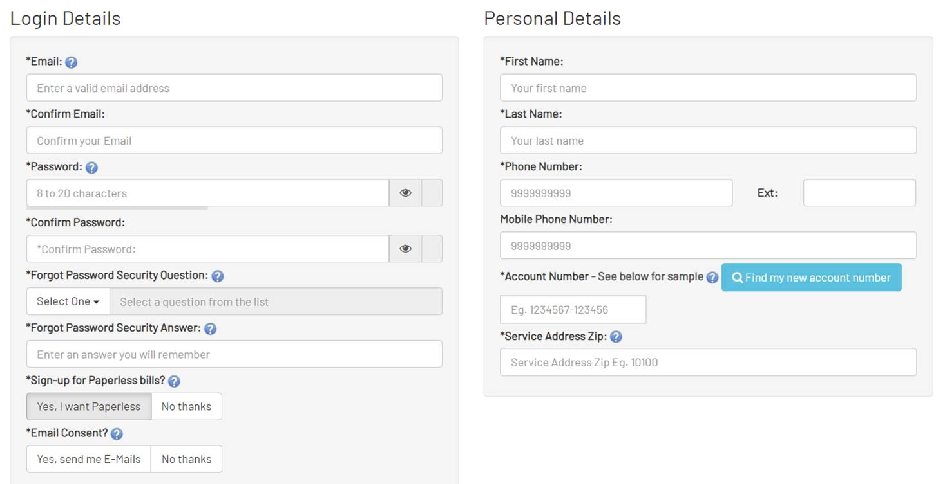

Let me know if you have any questions.

Kind Regards,

Finance Department

