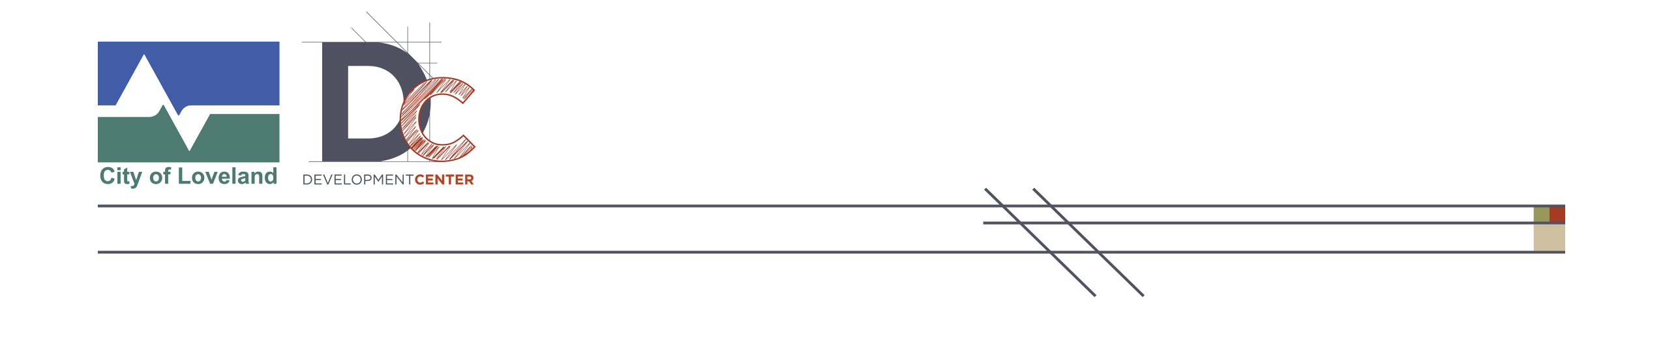

Public Hearing Notice Letter

Date: April 6, 2023

Dear Property Owner or Resident:

This is a notice that Planning Commission and City Council public hearings will be held to discuss the proposed rezone of four properties between West 6th St and Douglas Avenue.

Application and Meeting Information
Public Hearing Board  Meeting Date and Time | Planning Commission  6:00 p.m. on April 24, 2023
Public Hearing Board  Meeting Date and Time | City Council  6:00 p.m. on June 20, 2023
Application | Rezone
Project Case Numbers | PZ# 22-154
Project Name | 6th and Douglas Rezoning
Meeting Location | City Council Chambers, 500 East Third Street, Loveland, Colorado
Applicant Name | City of Loveland  Kerri Burchett, Principal Planner, Strategic Planning  Marika Kopp, Planner II, Current Planning

Project Description
Summary of Proposed Development | The application is a City-initiated effort to align zoning with existing uses and buildings in the 6th and Douglas area. The current zoning is R1e – Established Low Density Residential. The proposed zoning is R3e – Established High Density Residential.  Please refer to the online FAQ for more information about the proposal.  lovgov.org/services/development-services/current-planning/neighborhood-notices-meetings-administrative-decisions/6th-and-douglas-rezone-proposal
General Location | Located adjacent to the intersection of W. 6th St. and N. Douglas Ave. The attached map indicates the properties that were included in the original rezoning application and those that remain a part of the project.
Property Address | 1: 911, 913, 915, 917 W. 6th Street  2: 605 N California Ave  3: 905 W 6th Street  4: 914 W 6th Street
Zoning | Existing: R1e  Proposed: R3e
Legal Description | 1: Lot 1, Blk 1, California Addition  2: Lot 1, California 1st Subdivision  3: Lot 3, Blk 1, California Addition  4: Lots 5 Thru 8, Green Addition & Lots 1 Thru 4, Block 3, California
Additional Information | Additional information on the project is available at CityofLoveland.org/CDA

All interested parties may appear and speak on the matter at the public hearing and/or file written comments with the Current Planning Division.

Any written information that you intend to provide or present at the Planning Commission or City Council public hearing must be provided to the at least 1 week in advance of the hearing. This includes petitions, PowerPoint presentations, photos, letters, or other written information. Items submitted at the public hearing will not be accepted as they were not available for public review prior to the hearing. Information for the Planning Commission hearing may be submitted to Marika Kopp, marika.kopp@cityofloveland.org. Information for the City Council hearing shall be submitted to the Clerk.

If you have any questions regarding the proposed project please contact Kerri Burchett, 970.962.2566, Kerri.Burchett@cityofloveland.org or Marika Kopp, 970-962-2721, Marika.Kopp@cityofloveland.org

To request a copy of this letter in Spanish, free of charge, contact 970-962-2523 or email planning@cityofloveland.org. Para recibir una copia gratuita en español, llame al 970-962-2523 o envíe un correo electrónico a planning@cityofloveland.org.

Sincerely,

Kerri Burchett
Principal Planner
City of Loveland
Kerri.Burchett@cityofloveland.org
970-962-2566

Marika Kopp
Planner II
City of Loveland
Marika.Kopp@cityofloveland.org
970-962-2721

