CR-05 - Goals and Outcomes
Progress the jurisdiction has made in carrying out its strategic plan and its action plan. 91.520(a)
This could be an overview that includes major initiatives and highlights that were proposed and executed throughout the program year.

During the second year of the 2020-2024 Consolidated Plan, the City of Loveland expected to complete 21% of the 5-year goals, but only reached about 10%. By the end of the program year, the Homeless Housing project is on-track to exceed the five year goal by four units, although it will not be completed during the grant year. The Multi-Family Rehabilitation goal is on-track but the Single-Family Rehabilitation goal is unlikely to be met after five years. The Public Service and Public Facility goals will both likely be exceeded. Information and accomplishments by type of project include the following:
NEW HOUSING. A Permanent Supportive Housing project was funded during the program year. Ground was broken in August 2022 and 54 units of new multi-family housing will be completed and occupied by currently homeless residents in 2023. The New Housing goal will be 18% complete and the specific Homeless Housing goal will be exceeded.
PUBLIC FACILITIES. One organization received funding for a public facility project in 2020 that was combined with funding from 2021 to ensure enough money to complete the project. The Public Facility goal is 33% complete in terms of the number of projects expected over the five years of this Consolidated Plan, and about 10% of the number of people served in public facilities funded with CDBG.
PUBLIC SERVICES. 542 people received services from the agencies that received public service funding, which is about 11% of the five-year goal. Note that the expected public service program goal of 1,248 shown below was overstated by 863 from the Salvation Army project. The agency counted shelter nights instead of upduplicated customers served. A minor amendment to the Annual Action Plan to correct this mistake will be made in 2023.
HOUSING REHABILITATION. No housing rehabilitation projects were funded during the 2021-2022 program year, although a 2020-2021 rehabilitation project that served 72 households was recently completed, meeting the goal by 36%.
The Affordable Housing and Human Services Commissions used the accomplishment data from the 2015-2019 Consolidated Plan to determine outcomes for the current Consolidated Plan. Subsequent changes made by non-profit organizations after the plan was submitted, specifically single-family rehabilitation goal, are now at risk of not being met over the next five years, although the Community Partnership Office will not be reducing the potential number of project recipients.
City of Loveland CDBG-CV grants helped 242 households with utility assistance, 135 households with rent assistance, 19 people find new jobs, 94 people at the domestic violence shelter and 120 people using services from two day centers for persons with disabilities stay safe with on-going sanitizing of public facilities, 30 people with non-congregant shelter to recover from COVID-19 or a medical procedure or illness in a motel, 550 low-income youth with additional food, 101 people living in public housing access job assistance and other COVID related needs, 43 children or families with therapy stemming from child abuse, and 10,921 with a COVID-19 vaccination. Eighty percent (80%) of CDBG-CV funding has been spent to date.
Comparison of the proposed versus actual outcomes for each outcome measure submitted with the consolidated plan and explain, if applicable, why progress was not made toward meeting goals and objectives. 91.520(g)
Categories, priority levels, funding sources and amounts, outcomes/objectives, goal outcome indicators, units of measure, targets, actual outcomes/outputs, and percentage completed for each of the grantee’s program year goals.

Goal | Category | Source / Amount | Indicator | Unit of Measure | Expected – Strategic Plan | Actual – Strategic Plan | Percent Complete | Expected – Program Year | Actual – Program Year | Percent Complete
Create New Affordable Housing | Affordable Housing  Homeless | CDBG: $222142 | Rental units constructed | Household Housing Unit | 225 | 0 | 0.00% | 54 | 0 | 0.00%
Create New Affordable Housing | Affordable Housing  Homeless | CDBG: $222142 | Homeowner Housing Added | Household Housing Unit | 25 | 0 | 0.00%
Create New Affordable Housing | Affordable Housing  Homeless | CDBG: $222142 | Housing for Homeless added | Household Housing Unit | 50 | 0 | 0.00%
New or Rehabilitated Public Facility | Homeless  Non-Homeless Special Needs  Non-Housing Community Development | CDBG: $38750 | Public Facility or Infrastructure Activities other than Low/Moderate Income Housing Benefit | Persons Assisted | 300 | 28 | 9.33% | 28 | 28 | 100.00%
New or Rehabilitated Public Facility | Homeless  Non-Homeless Special Needs  Non-Housing Community Development | CDBG: $38750 | Homeless Person Overnight Shelter | Persons Assisted | 0 | 0 |  | 0 | 0
New or Rehabilitated Public Facility | Homeless  Non-Homeless Special Needs  Non-Housing Community Development | CDBG: $38750 | Overnight/Emergency Shelter/Transitional Housing Beds added | Beds | 0 | 0 |  | 0 | 0
Public Service Activities | Homeless  Non-Homeless Special Needs | CDBG: $60100 | Public service activities other than Low/Moderate Income Housing Benefit | Persons Assisted | 5000 | 1020 | 20.40% | 1248 | 542 | 43.43%
Public Service Activities | Homeless  Non-Homeless Special Needs | CDBG: $60100 | Homeless Person Overnight Shelter | Persons Assisted | 0 | 57 |  | 0 | 0
Public Service Activities | Homeless  Non-Homeless Special Needs | CDBG: $60100 | Overnight/Emergency Shelter/Transitional Housing Beds added | Beds | 0 | 48 |  | 0 | 48
Rehabilitate Affordable Housing | Affordable Housing |  | Rental units rehabilitated | Household Housing Unit | 200 | 0 | 0.00%
Rehabilitate Affordable Housing | Affordable Housing |  | Homeowner Housing Added | Household Housing Unit | 0 | 0 |  | 0 | 0
Rehabilitate Affordable Housing | Affordable Housing |  | Homeowner Housing Rehabilitated | Household Housing Unit | 700 | 0 | 0.00% | 0 | 0
Table 1 - Accomplishments – Program Year & Strategic Plan to Date

Assess how the jurisdiction’s use of funds, particularly CDBG, addresses the priorities and specific objectives identified in the plan, giving special attention to the highest priority activities identified.
The highest priority for City of Loveland CDBG funding is building new affordable single- or multi-family housing, or new housing for homeless residents. A Permanent Supportive Housing project was funded and will house 54 currently homeless residents in 2023.
The second priority is funding the rehabilitation of single- or multi-family housing. One multi-family project was funded in 2020 and was recently completed.
The last priority for brick/mortar funding is new public facilities or public facility rehabilitation. A fire suppression project was was funded in both 2020 and 2021 and was completed in 2022.
Public service activities are funded every year. The City of Loveland always allocates 15% of CDBG to public services.
Priorities identified during the 2015-2019 Consolidated Plan have been continued in the 2020-2024 Consolidated Plan with an update to the potential number served. Priorities have not changed.

CR-10 - Racial and Ethnic composition of families assisted
Describe the families assisted (including the racial and ethnic status of families assisted). 91.520(a)

 | CDBG
White | 470
Black or African American | 22
Asian | 0
American Indian or American Native | 28
Native Hawaiian or Other Pacific Islander | 5

Total | 525

Hispanic | 120
Not Hispanic | 570

Table 2 – Table of assistance to racial and ethnic populations by source of funds

Narrative
The attached (Fair Housing Data) report includes data not entered into IDIS. The race table above does not include all categories, leaving 45 (multi-racial) people uncounted. The total should be 570 as reflected in the Not Hispanic boxes. Overall, City of Loveland sub-recipients served a lower percentage of White, Asian & White, and Multi-racial residents.

CR-15 - Resources and Investments 91.520(a)
Identify the resources made available
Source of Funds | Source | Resources Made Available | Amount Expended During Program Year
CDBG | public - federal | 401,124 | 249,475
Table 3 - Resources Made Available

Narrative
The City of Loveland received a 2021-2022 CDBG award of $379,663 and had $21,461 in program income. $249,475 was spent during the program year: $91,399.91 from project funded prior to 2021 and $158,075.19 from 2021-2022 project.
In 2020, four acres of land owned by the City of Loveland was granted to Archdiocesan Housing to build Supportive Housing in Loveland. A 9% Low Income Housing Tax Credit award was received by Archdiocesan Housing in 2021. A ground breaking ceremony took place in August 2022, and the project is expected to be completed in the fall of 2023.

Identify the geographic distribution and location of investments
Target Area | Planned Percentage of Allocation | Actual Percentage of Allocation | Narrative Description
Table 4 – Identify the geographic distribution and location of investments

Narrative
The City of Loveland does not distribute grant funding based on a Target Area. Instead, all funding is used for housing or services for residents living at or below 80% of the Area Median Income.
Leveraging
Explain how federal funds leveraged additional resources (private, state and local funds), including a description of how matching requirements were satisfied, as well as how any publicly owned land or property located within the jurisdiction that were used to address the needs identified in the plan.
The attached FHEO Data Report shows that City of Loveland CDBG leveraged more than $18 million in other funding from 2021-2022 Loveland projects, and almost $6.5 million in CDBG-CV, primarily from State rental assistance funding that was distributed by Neighbor to Neighbor.
There were no matching requirements for CDBG or CDBG-CV.

CR-20 - Affordable Housing 91.520(b)
Evaluation of the jurisdiction's progress in providing affordable housing, including the number and types of families served, the number of extremely low-income, low-income, moderate-income, and middle-income persons served.

 | One-Year Goal | Actual
Number of Homeless households to be provided affordable housing units | 54 | 0
Number of Non-Homeless households to be provided affordable housing units | 0 | 0
Number of Special-Needs households to be provided affordable housing units | 0 | 0
Total | 54 | 0
Table 11 – Number of Households

 | One-Year Goal | Actual
Number of households supported through Rental Assistance | 0 | 0
Number of households supported through The Production of New Units | 54 | 0
Number of households supported through Rehab of Existing Units | 0 | 0
Number of households supported through Acquisition of Existing Units | 0 | 0
Total | 54 | 0
Table 12 – Number of Households Supported

Discuss the difference between goals and outcomes and problems encountered in meeting these goals.
Archdiocesean Housing received funding to build 54 units of Supportive Housing that will be completed I 2023 to meet the goal shown above. Multi-family housing always takes more than a year to build.
Discuss how these outcomes will impact future annual action plans.
After the second year results from the 2020-2024 Consolidated Plan, the City of Loveland believes that it will be difficult to meet the single-family housing rehabilitation goal but will likely meet the multi-family housing rehabilitation goal.
Include the number of extremely low-income, low-income, and moderate-income persons served by each activity where information on income by family size is required to determine the eligibility of the activity.

Number of Households Served | CDBG Actual | HOME Actual
Extremely Low-income | 0 | 0
Low-income | 0 | 0
Moderate-income | 0 | 0
Total | 0 | 0
Table 13 – Number of Households Served

Narrative Information
The Supportive Housing project will serve presumed benefit persons.

CR-25 - Homeless and Other Special Needs 91.220(d, e); 91.320(d, e); 91.520(c)
Evaluate the jurisdiction’s progress in meeting its specific objectives for reducing and ending homelessness through:
Reaching out to homeless persons (especially unsheltered persons) and assessing their individual needs
Loveland has a non-profit based street outreach team called (House of Neighborly Service) 137 MASH and a faith-based outreach team called The Servant’s Heart. The City of Loveland recently submitted a proposal to create a regional street outreach project with individual teams in Fort Collins, Loveland and Greeley providing the same services to enter unsheltered residents into the Homeless Management Information System (HMIS) and the By-Name List (BNL) to understand the complete number of people experiencing homelessness in northern Colorado. Whether funding will be received is not yet known.
Service providers such as House of Neighborly Service/ Family Promise, Disabled Resource Services, Community Kitchen, SummitStone Health Partners and Salvation Army have regular contact with unsheltered residents, although rarely outside of a public facility.
Northern Colorado still has a robust Coordinated Entry system in spite of the pandemic and has housed 1,340 people over the last six years. Since 2016, Northern Colorado service providers have housed 474 veterans (90%), 459 non-veteran adults (57%), 393 families (90%), and 14 youth (47%). Street outreach will increase the number of people entered onto the BNL so the total percentage of people housed to date (75%) is expected to decrease over the next six months to a year.
Addressing the emergency shelter and transitional housing needs of homeless persons
The City of Loveland Community Partnership Office is now providing shelter for adults with an almost 24/7 program. The city does not have emergency shelter for families, although the Family Promise program of the House of Neighborly Service shelters up to four families that are participating in their program.
Loveland currently has five units of transitional housing. The number has not increased for many years.
Helping low-income individuals and families avoid becoming homeless, especially extremely low-income individuals and families and those who are: likely to become homeless after being discharged from publicly funded institutions and systems of care (such as health care facilities, mental health facilities, foster care and other youth facilities, and corrections programs and institutions); and, receiving assistance from public or private agencies that address housing, health, social services, employment, education, or youth needs
The City of Loveland funds local non-profits through a competitive process but does not set aside funding for specific outcomes, such as organizations working with residents who are likely be become homeless after having been discharged from an institution or system of care. During the 2021 program year, funded organizations that kept residents from becoming homeless include Alternatives to Violence providing safehousing for survivors of family violence, Loveland Habitat for Humanity by providing affordable housing, and Project Self Sufficiency by providing services that result in families making a living wage as well as housing for some customers.
Other funded agencies working on housing, health, social services, employment, or youth needs include:
- The Loveland Housing Authority providing emergency grants and no/low interest loans for housing rehabilitation to keep families housed;
- Boys & Girls Club, Teaching Tree, Thompson Valley Preschool, Chilren’s Speech and Reading Center, and Colorado Youth for a Change proving child care and education for youth; and
- Family Housing Network providing re-housing (and shelter) for families experiencing homeless.
Some of the listed projects were funded with City of Loveland general tax dollars and not CDBG.
The Community Partnership Office does not work with publicly funded institutions and systems of care to help people from becoming homeless after they have been discharged, but does work with agencies that do, including the Salvation Army that will put an individual or family in a motel after discharge from the hospital, and Homeward Alliance and Volunteers of America to find housing and other assistance for people exiting jail or prison. Northern Colorado does not currently have housing for people right after they leave an institutional setting.
Helping homeless persons (especially chronically homeless individuals and families, families with children, veterans and their families, and unaccompanied youth) make the transition to permanent housing and independent living, including shortening the period of time that individuals and families experience homelessness, facilitating access for homeless individuals and families to affordable housing units, and preventing individuals and families who were recently homeless from becoming homeless again
Coordinated Entry results are described above. In addition, the House of Neighborly Service/Family Promise program works to help homeless families find employment and pay past debts to become self-sufficient when they graduate from the program into permanent housing.
The 54 units of Permanent Supportive Housing that will be built by Archdiocesan Housing, with partners BlueLine Development and Shop Works Architecture, will end homelessness for 54 residents. A conceptual housing project that could bring between 40 and 44 micro-units to Loveland is also under discussion and if funded by the Division of Housing, will further reduce the number of people living outside.

CR-30 - Public Housing 91.220(h); 91.320(j)
Actions taken to address the needs of public housing
The City of Loveland addresses public housing needs by allocating grants and other funding to organizations that provide housing. During the 2021-2022 program year, Archdiocesan Housing was allocated $222,142 in CDBG and a waiver of building and development fees in the amount of $1,146,321 to build 54 units of Permanent Supportive Housing. In 2020, the Loveland Housing Authority received $211,522 in CDBG and a waiver of fees in the amount of $161,121 to rehabilitate 72 units of affordable housing in the Brookstone apartment complex. In 2019, the Housing Authority received a waiver of close to $1.2 million in building and development fees for 69 units of multi-family housing as well as $200,000 in CDBG. In 2018, the organization received a waiver of fees totaling $1.25 million for 60 units of new housing, $257,414 for 30 units of skilled nursing and $97,575 to rehabilitate 60 units of affordable multi-family housing.
Over the last four years, the Loveland City Council waived $4.1 million in fees for 345 units of multi-family housing and skilled nursing units for Loveland residents. Fee waiver are vital to increasing the affordable housing stock in Loveland given the small amount of CDBG received each year.
Actions taken to encourage public housing residents to become more involved in management and participate in homeownership
The Loveland Housing Authority started a non-profit service organization about four years ago. Aspire 3D, through a partnership with Loveland Housing Authority, works with residents to provide site based, resident driven solutions to both individual and community needs or concerns. The organization launched a Leadership Council in four Housing Authority communities: Orchard Place, The Edge, Silver Leaf and Mirasol. Residents meet monthly to identify community strengths and challenges, develop and implement solutions and build social connections. This approach to resident engagement ensures that programs and activities better meet the needs of unique communities and are more sustainable, long term solutions. In addition to the resident lead group work, staff navigators provide client centered work with each resident to identify their goals, barriers and steps to achieve self-sufficiency to break the cycle of generational poverty and ultimately transition out of low-income housing to home ownership. While these actions may not directly result in homeownership, they are expected to stabilize families to be able to move on from low income housing.
Actions taken to provide assistance to troubled PHAs
The Loveland Housing Authority is not designated as troubled.

CR-35 - Other Actions 91.220(j)-(k); 91.320(i)-(j)
Actions taken to remove or ameliorate the negative effects of public policies that serve as barriers to affordable housing such as land use controls, tax policies affecting land, zoning ordinances, building codes, fees and charges, growth limitations, and policies affecting the return on residential investment. 91.220 (j); 91.320 (i)
The City's strategy to remove barriers and provide incentives to developers and builders of affordable housing include use tax credits and the waiver or reduction of development fees, capital expansion and building permit fees. The City of Loveland adopted an affordable housing code to encourage the building of low-income housing in 1994, and updated incentives for single-family and multi-housing projects in 2017. The Planning and Zoning codes were re-written and officially adopted at the start of 2019, and now include the ability to build homes as small as 400 square feet with minimal setbacks and a reduction in parking. These changes are designed to make housing more affordable. Additional work is underway to ensure the changes work to provide a lower costing home.
In late 2020, the Loveland City Council asked the Loveland Housing Authority to look for solutions that address housing affordability challenges. In 2021, the Housing Authority convened local leaders to create the Loveland Affordable Housing Task Force, an ad hoc group of private, public, and non-profit housing sector leaders, along with other concerned members of the community representing various industries and perspectives. In 2022, the Task Force made several recommendations, including zoning changes, partnering with the private sector, creating a tiered fee structure for smaller units, creating a market rate housing loan fund, and starting a land bank. While none of the recommendations have been adopted, City Council is interested in continuing the discussion.
Actions taken to address obstacles to meeting underserved needs. 91.220(k); 91.320(j)
The Community Partnership Office is now responsible for providing shelter for homeless residents and is working toward creating a 24/7 program located on two sites, one for day services and one for overnight shelter. A camping ban in May provided an opportunity to expand homeless services in Loveland and is almost certain to result in more people receiving housing.
Community Partnership Office staff continue to discuss program accessibility with funded agencies, including the manner in which the working poor access services that may only be available during regular business hours. The Human Services and Affordable Housing Commissions continue to discuss program improvements during the annual grant process to better understand the experience of non-profit customers.
Actions taken to reduce lead-based paint hazards. 91.220(k); 91.320(j)
The Community Partnership Office requires that all activities funded with CDBG dollars comply with federal regulations concerning lead-based paint. The City does not have a funded program for reducing lead-paint hazards in general and no homes were made completely lead free during the program year.
In 2021 and 2022, the Community Partnership Office worked with Volunteers of America/Handyman program and Loveland Housing Authority/Larimer Home Improvement program to increase their knowledge of lead paint regulations and take additional precautions to keep families safe while providing necessary home rehabilitation.
Actions taken to reduce the number of poverty-level families. 91.220(k); 91.320(j)
The City of Loveland allocates $460,000 in grant funding to services organizations in addition to CDBG public service dollars. All funded agencies work with low to moderate income individuals with most individuals living at or below the poverty line. The City of Loveland is also a direct service provider, which provides the opportunity to ensure that people living at the lowest end of poverty are able to connect to basic needs services and housing.
Actions taken to develop institutional structure. 91.220(k); 91.320(j)
The Community Partnership Office continues to participate in the Northern Colorado Continuum of Care as a governing board member, member of the point-in-time count working group, and NOFA committee to help build institutional structures around accessing homeless programs and services. Community Partnership Office staff has also provided a structure for non-profit agencies to increase access to services as stated below.
Actions taken to enhance coordination between public and private housing and social service agencies. 91.220(k); 91.320(j)
The Community Partnership Office has a program to help ensure that funded services are accessible to the residents who need them by hosting a monthly meeting to have agency staff share program information. Agency representatives provide information such as the type of identification needed for services, hours of operation, and whether the agency serves undocumented individuals. The goal of the meeting was to ensure that an organization provides a warm hand-off to another organization versus providing a referral. The program was discontinued during the pandemic. The Community Partnership Office will discuss continuing the program in 2023.
The Community Partnership Office has been working with several private housing developers to try to increase the number and type of affordable housing in the City. A project that will produce 60-70 new single family homes started in 2021, with a two-bedroom home for sale around $255,000.
Identify actions taken to overcome the effects of any impediments identified in the jurisdictions analysis of impediments to fair housing choice. 91.520(a)
The City of Loveland completed an Assessment of Fair Housing in 2018.
In 2019 and 2020, the City of Loveland completed a Fair Housing Loveland Actions document that was submitted with the CAPER. Because comments have not been received, the Community Partnership Office will wait to complete another iteration to better understand if the actions taken by the City of Loveland over the past few years keep us on-track with actions taken.

CR-40 - Monitoring 91.220 and 91.230
Describe the standards and procedures used to monitor activities carried out in furtherance of the plan and used to ensure long-term compliance with requirements of the programs involved, including minority business outreach and the comprehensive planning requirements
The Community Partnership Office strives to complete monitoring of all projects within six months of project completion and has hired an additional staff member to complete the monitoring of older projects and meet the six month deadline going forward. A shorter monitoring form was developed in 2020 for projects that are regularly funded using CDBG and has increased the speed with which projects are monitored. A full monitoring will occur for regularly funded projects at least every three years.
For all CDBG funded projects, the Community Partnership Office has been working with subrecipients on general Title VI, ADA and grievance policies and procedures and started working with agencies on Limited English Proficiency and Effective Communication policies with the help of a national expert in 2021. A meeting with local non-profits was mandatory for agencies that receive Community Development Block Grant funding from the City of Loveland and highly encouraged for agencies that receive other Federal funding. Follow-up will include ensuring completed plans are accessible to customers of funded organizations. At some point, the ability to apply for any City of Loveland Community Partnership Office funding will be dependent on completing these vital documents. The Community Partnership Office hopes to move this project forward in 2023.
Minority business outreach information is gathered quarterly.

Citizen Participation Plan 91.105(d); 91.115(d)
Describe the efforts to provide citizens with reasonable notice and an opportunity to comment on performance reports.
Efforts to provide citizens with an opportunity to comment on performance include a 15 days comment period that began the day after a Public Hearing that was held on December 13, 2022. The Public Hearing was advertised in the Reporter-Herald and was placed on the Community Partnership Office website. The Citizen Participation Plan states that the Community Partnership Office staff will also advertise on Facebook and Twitter. The CPO Facebook page has been taken down at the request of the Office of Communication and Engagement. Staff will work on advertising on other City of Loveland social media platforms in the near future. A draft version of the report was sent to the Affordable Housing and Human Services Commissions, as well as funded agencies.
No one attended the public hearing that was held on December 13, 2022. No comments were received during the public comment period.
CR-45 - CDBG 91.520(c)
Specify the nature of, and reasons for, any changes in the jurisdiction’s program objectives and indications of how the jurisdiction would change its programs as a result of its experiences.
None of the program objectives were changed.
Does this Jurisdiction have any open Brownfields Economic Development Initiative (BEDI) grants?
No
[BEDI grantees] Describe accomplishments and program outcomes during the last year.

CR-45 - CDBG 91.520(c)
Specify the nature of, and reasons for, any changes in the jurisdiction’s program objectives and indications of how the jurisdiction would change its programs as a result of its experiences.
None of the program objectives were changed.
Does this Jurisdiction have any open Brownfields Economic Development Initiative (BEDI) grants?
No
[BEDI grantees] Describe accomplishments and program outcomes during the last year.

CR-58 – Section 3
Identify the number of individuals assisted and the types of assistance provided

Total Labor Hours | CDBG | HOME | ESG | HOPWA | HTF
Total Number of Activities | 0 | 0 | 0 | 0 | 0
Total Labor Hours
Total Section 3 Worker Hours
Total Targeted Section 3 Worker Hours
Table 15 – Total Labor Hours

Qualitative Efforts - Number of Activities by Program | CDBG | HOME | ESG | HOPWA | HTF
Outreach efforts to generate job applicants who are Public Housing Targeted Workers
Outreach efforts to generate job applicants who are Other Funding Targeted Workers.
Direct, on-the job training (including apprenticeships).
Indirect training such as arranging for, contracting for, or paying tuition for, off-site training.
Technical assistance to help Section 3 workers compete for jobs (e.g., resume assistance, coaching).
Outreach efforts to identify and secure bids from Section 3 business concerns.
Technical assistance to help Section 3 business concerns understand and bid on contracts.
Division of contracts into smaller jobs to facilitate participation by Section 3 business concerns.
Provided or connected residents with assistance in seeking employment including: drafting resumes,preparing for interviews, finding job opportunities, connecting residents to job placement services.
Held one or more job fairs.
Provided or connected residents with supportive services that can provide direct services or referrals.
Provided or connected residents with supportive services that provide one or more of the following: work readiness health screenings, interview clothing, uniforms, test fees, transportation.
Assisted residents with finding child care.
Assisted residents to apply for, or attend community college or a four year educational institution.
Assisted residents to apply for, or attend vocational/technical training.
Assisted residents to obtain financial literacy training and/or coaching.
Bonding assistance, guaranties, or other efforts to support viable bids from Section 3 business concerns.
Provided or connected residents with training on computer use or online technologies.
Promoting the use of a business registry designed to create opportunities for disadvantaged and small businesses.
Outreach, engagement, or referrals with the state one-stop system, as designed in Section 121(e)(2) of the Workforce Innovation and Opportunity Act.
Other.
Table 16 – Qualitative Efforts - Number of Activities by Program

Narrative
The City of Loveland has one project that is subject to Section 3. That project has just started so reporting data is not yet available.

Attachment
Cover Page
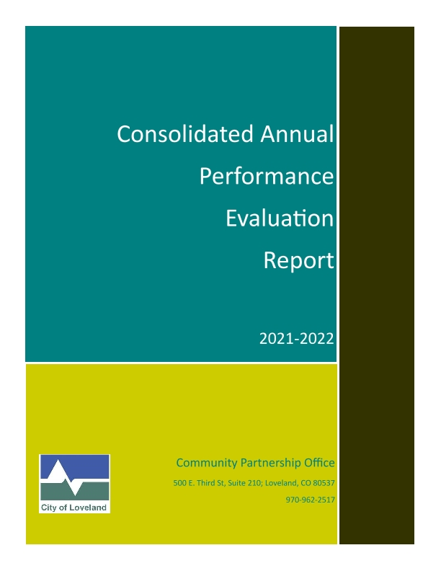

Executive Summary
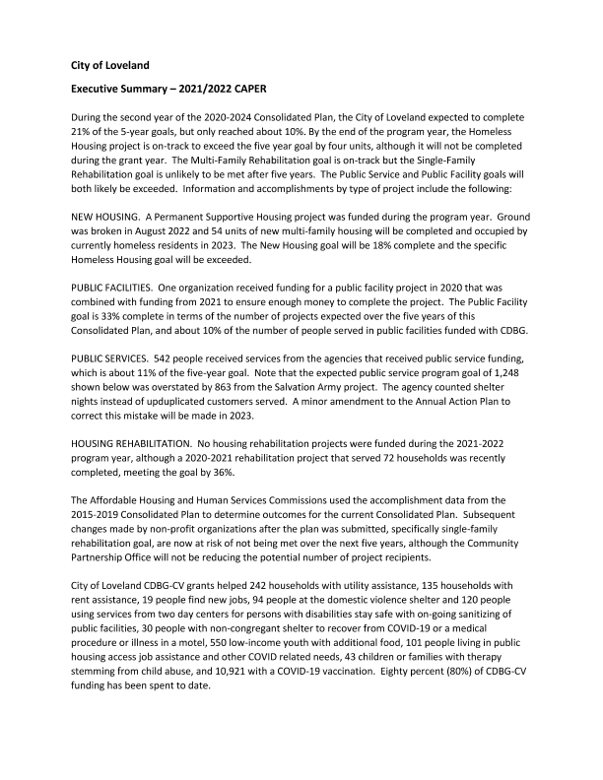
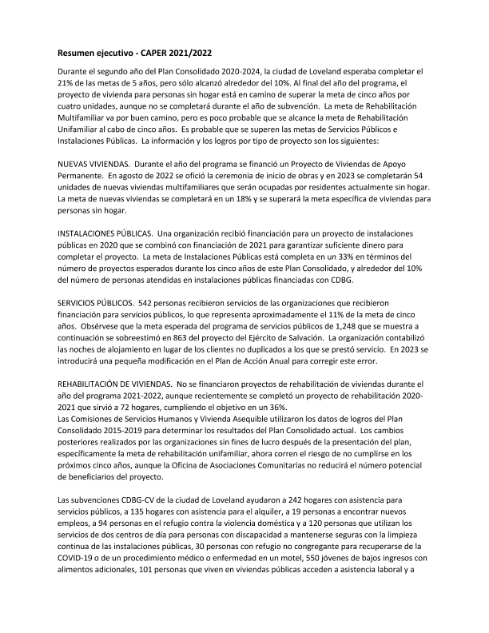
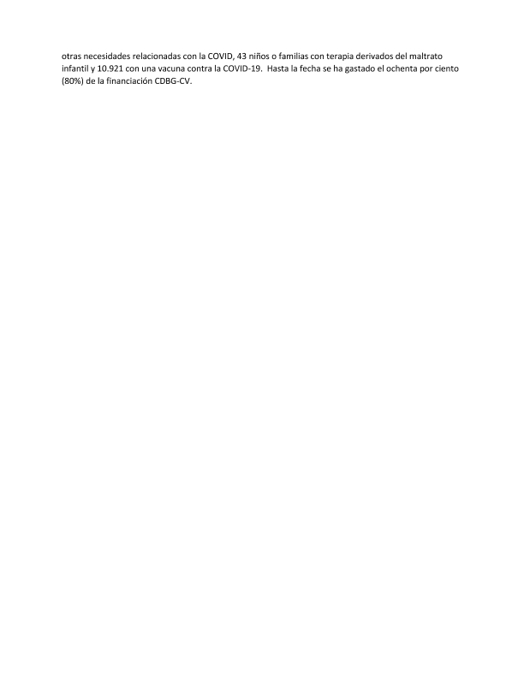

FHEO Supplemental
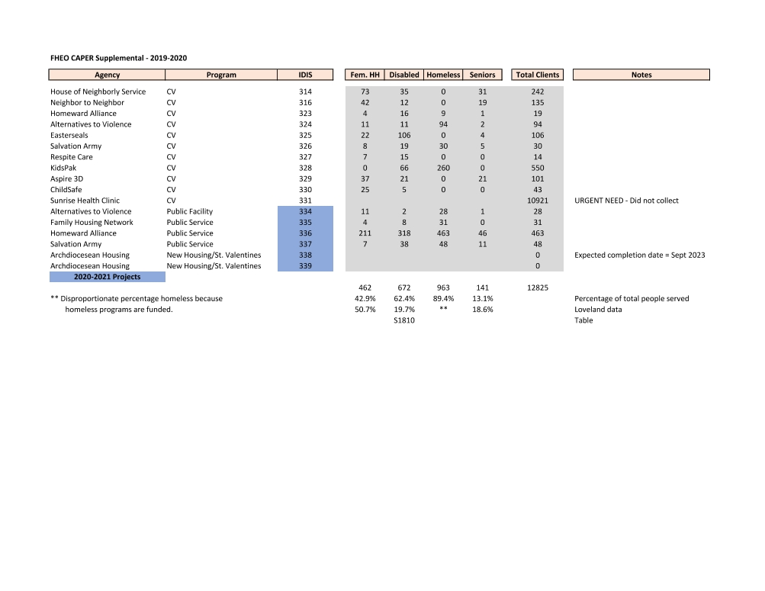
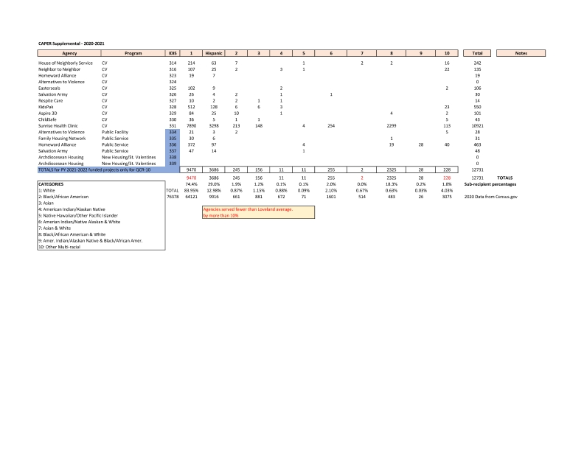
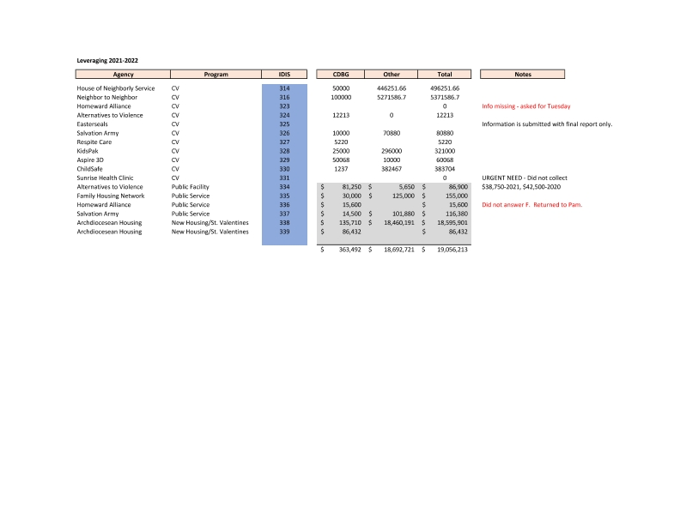
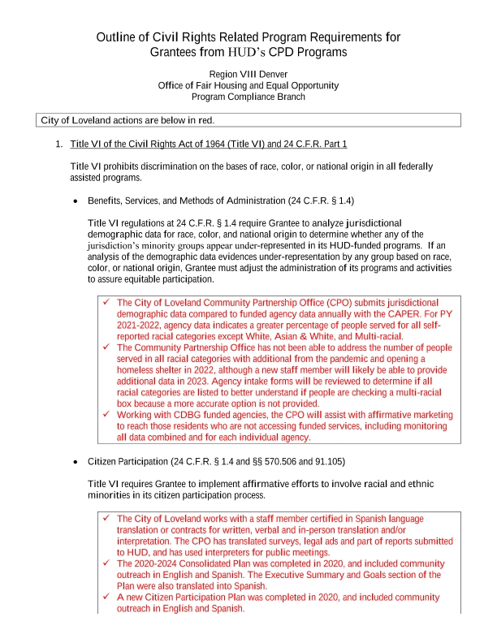
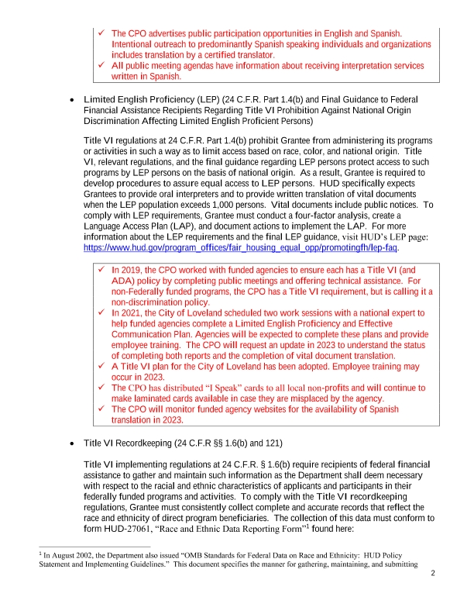
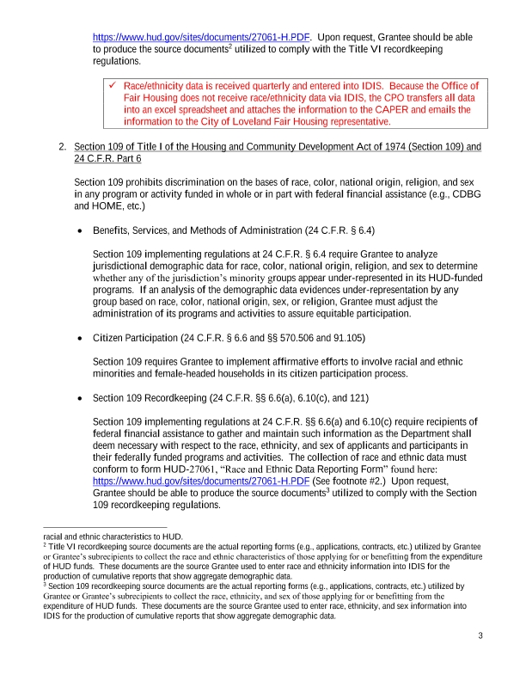
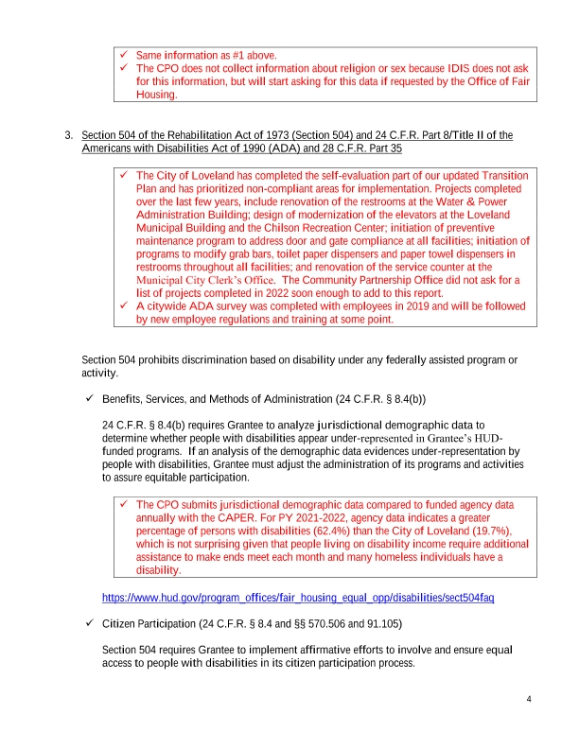
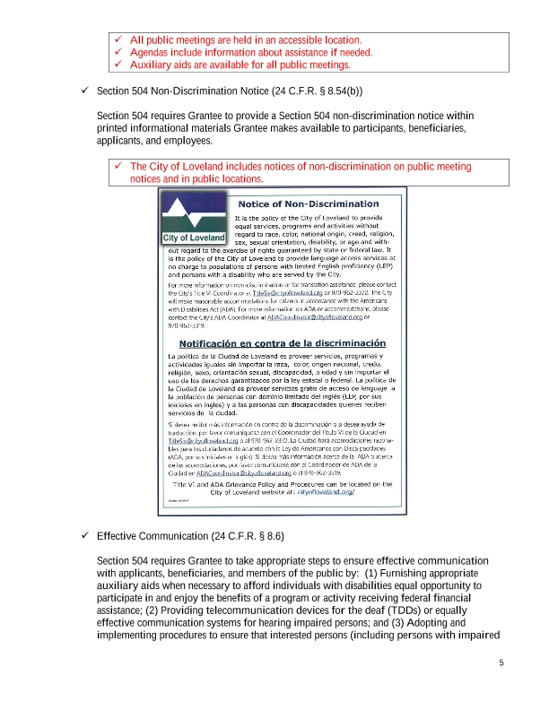
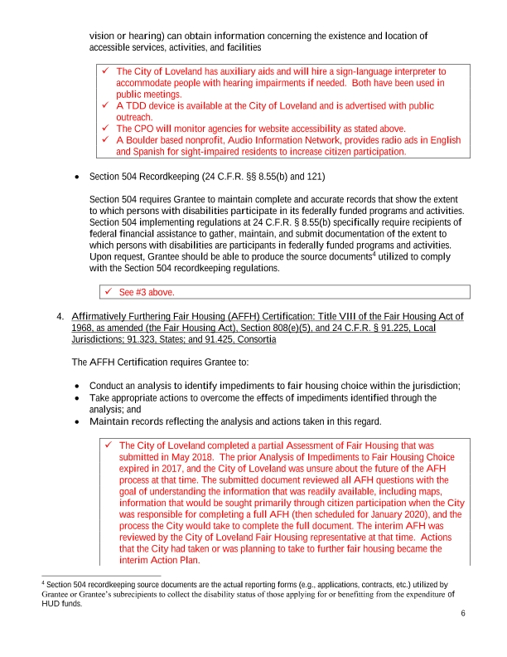
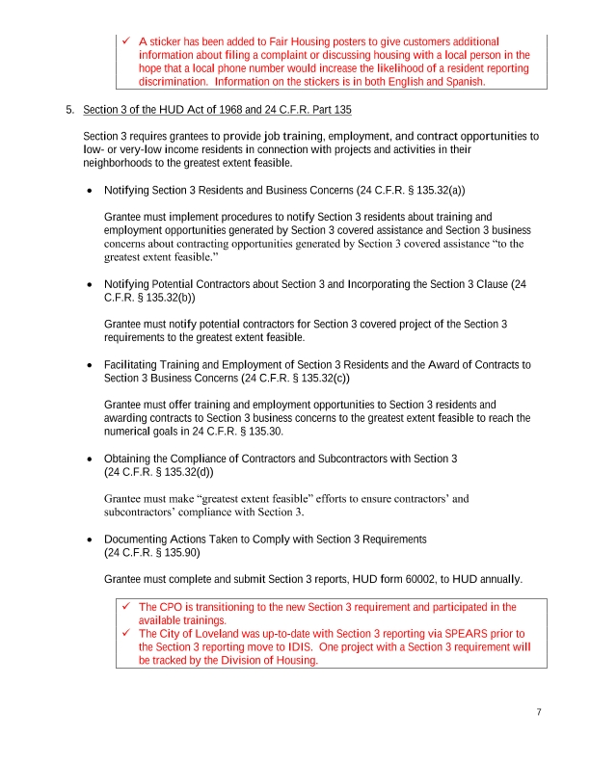
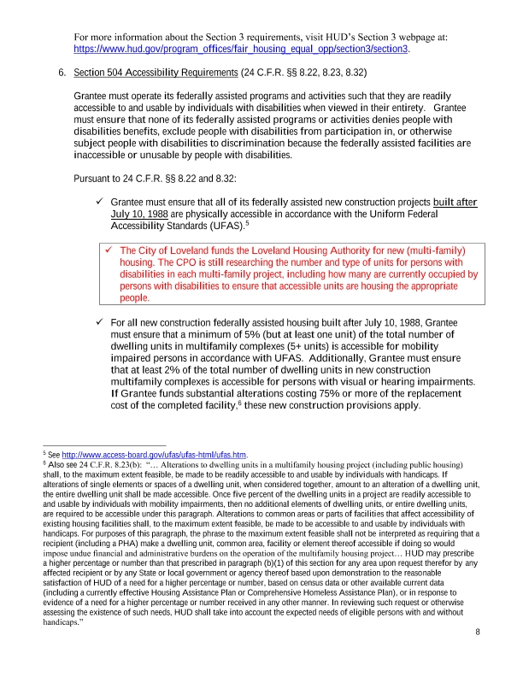
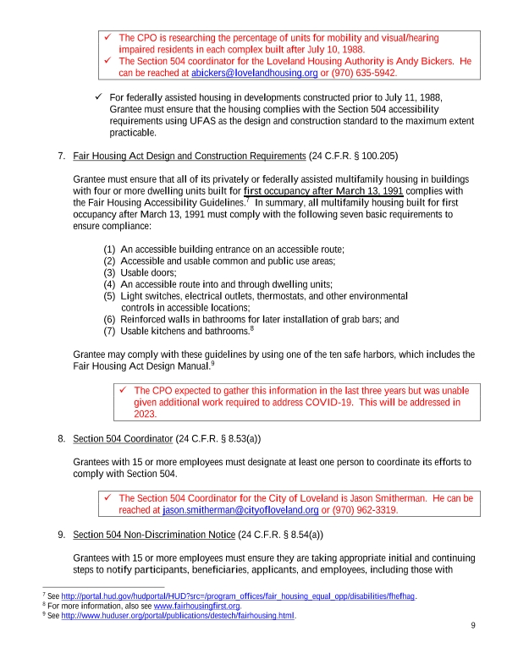
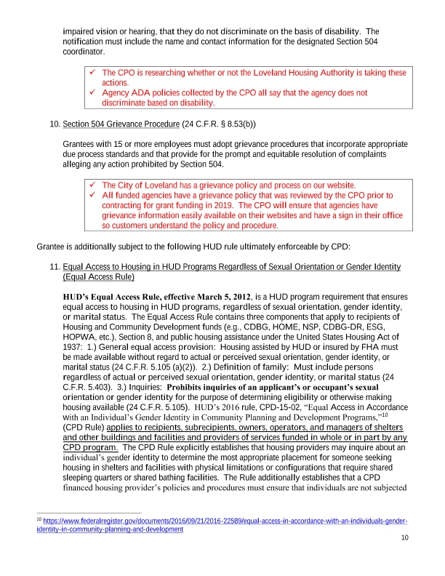
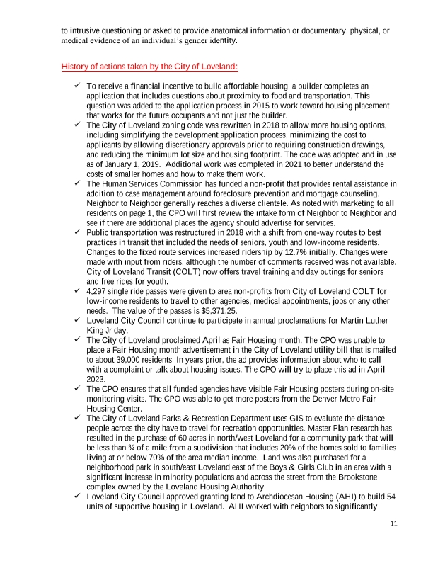
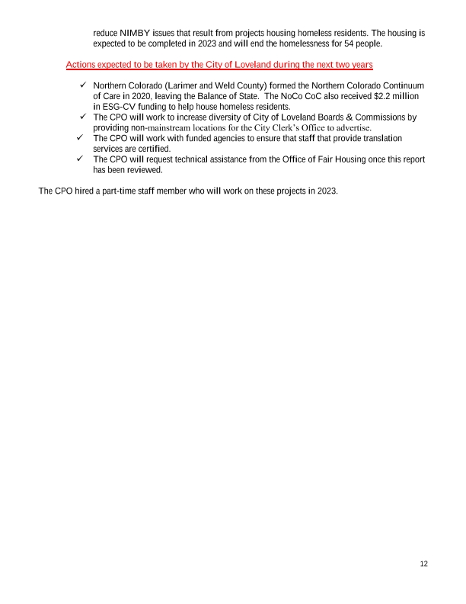

PR26 Reports and Reconciliation
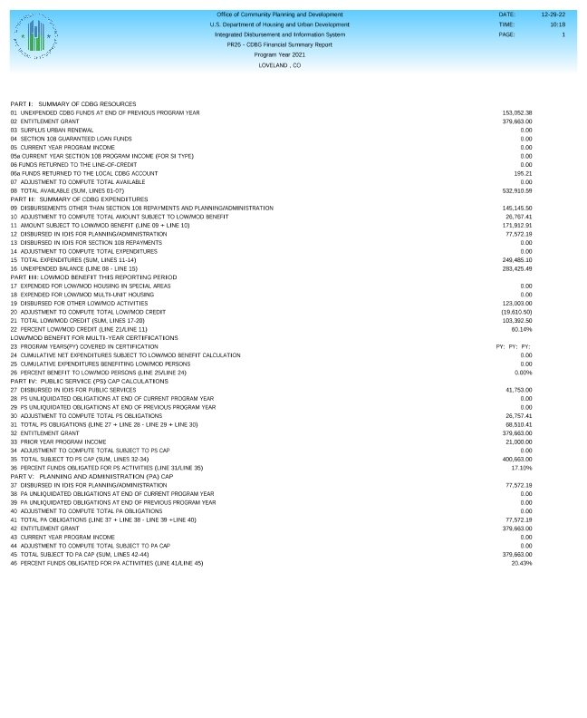
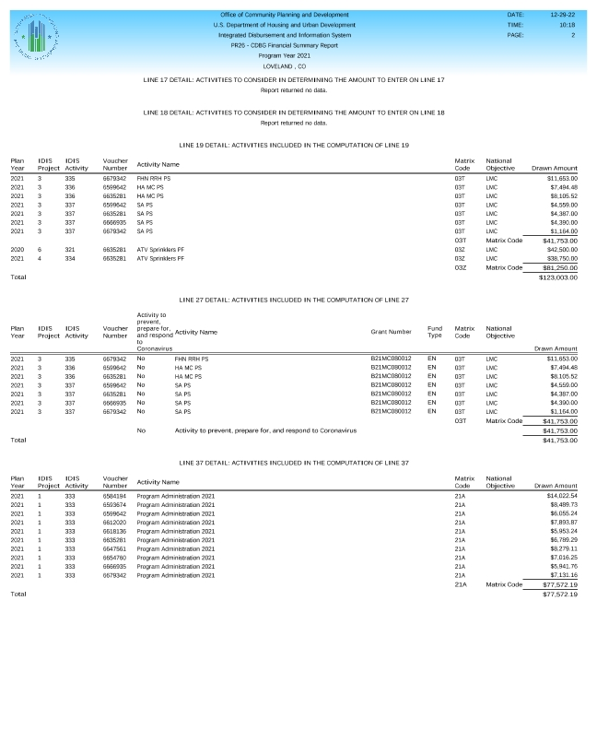
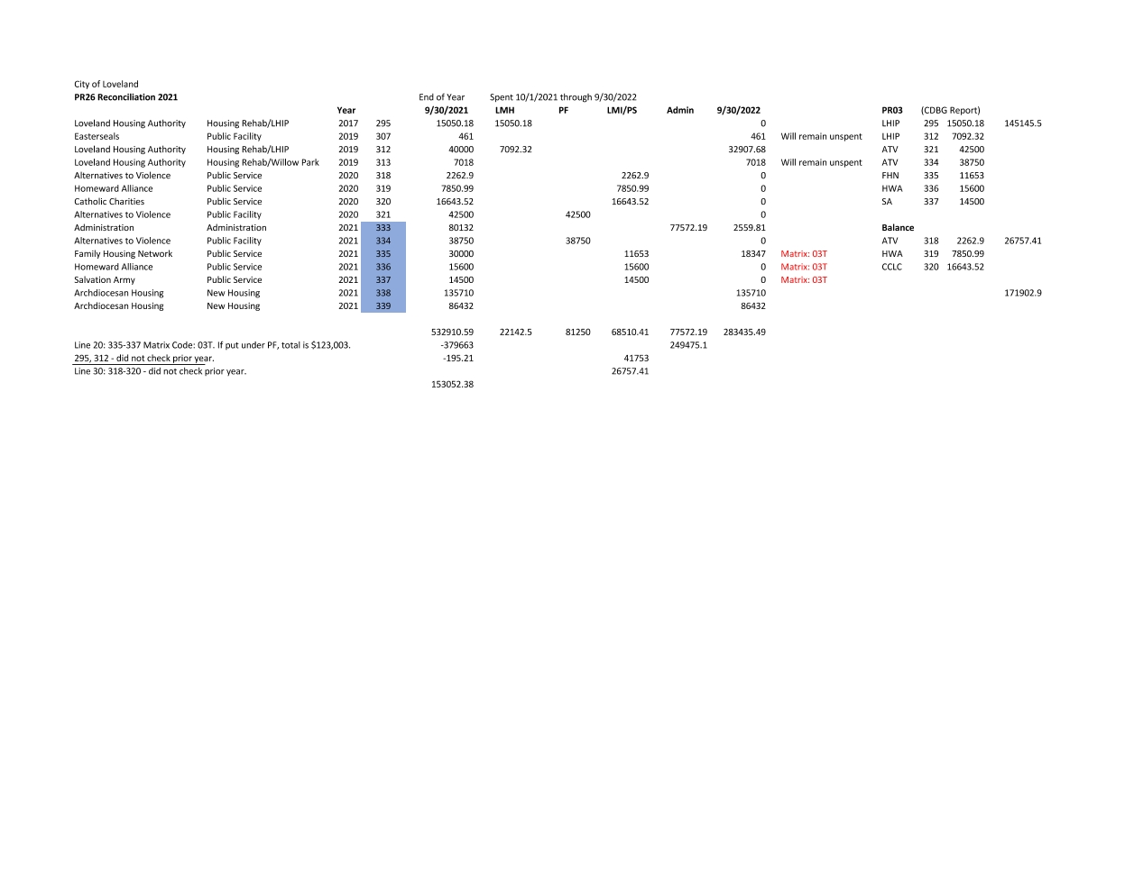
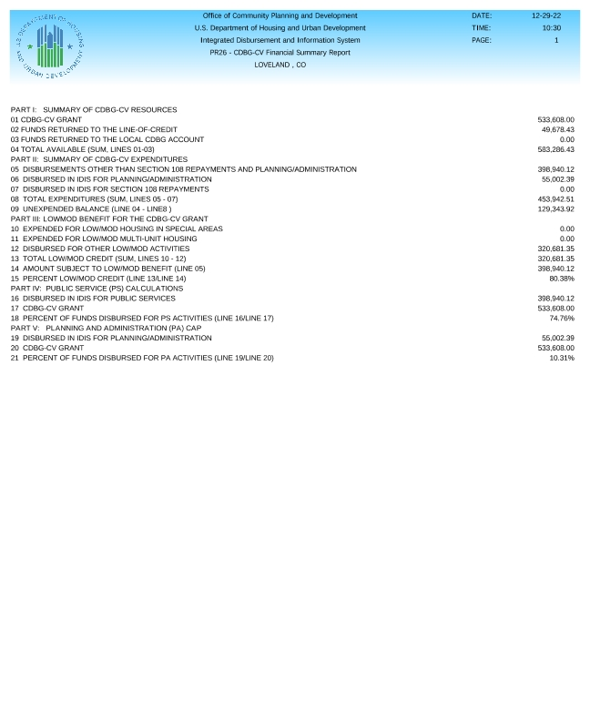
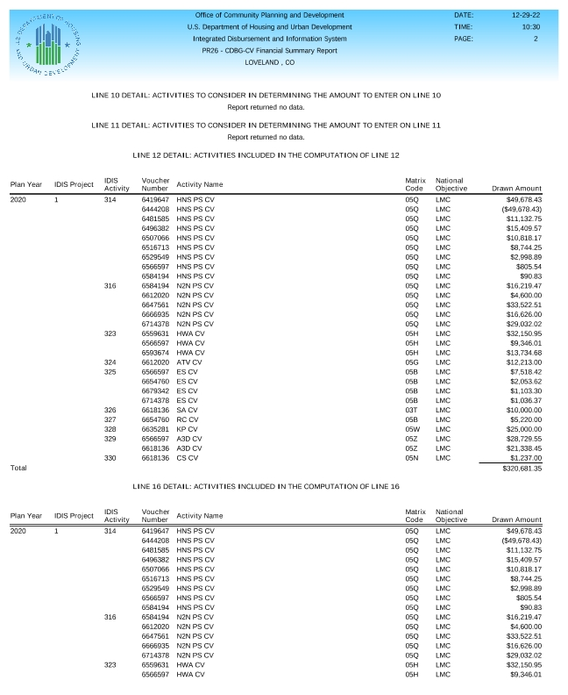
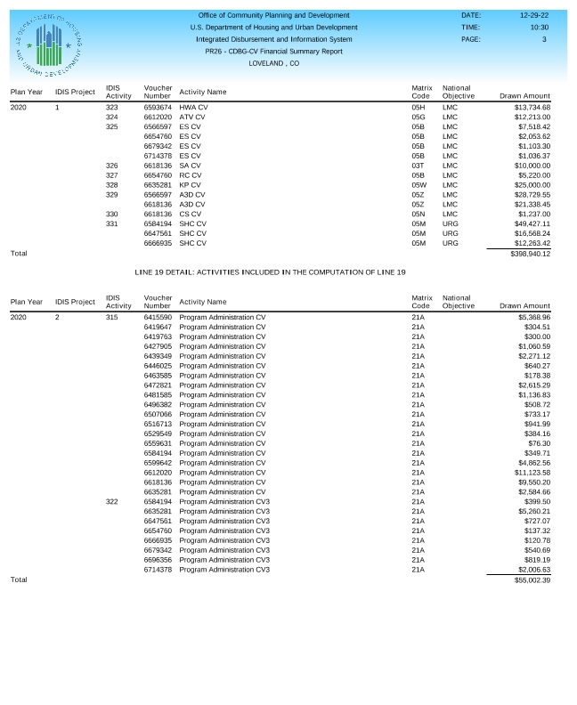
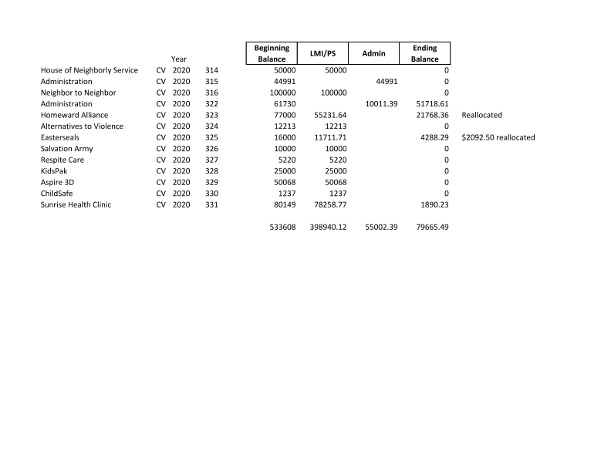

Public Notice
