Community Partnership Office Website: Grant Forms & Information

Google City of Loveland Community Partnership Office and click on Community Partnership Office l City of Loveland:
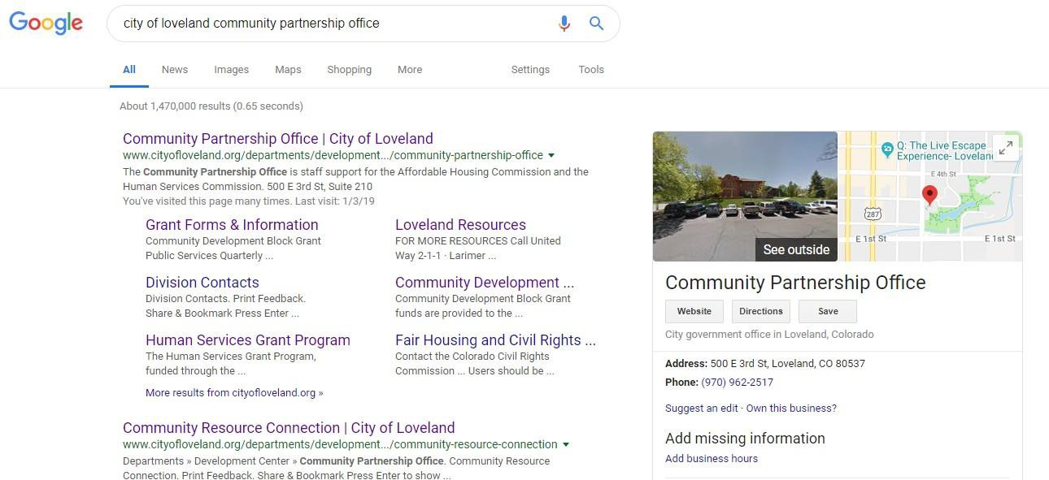

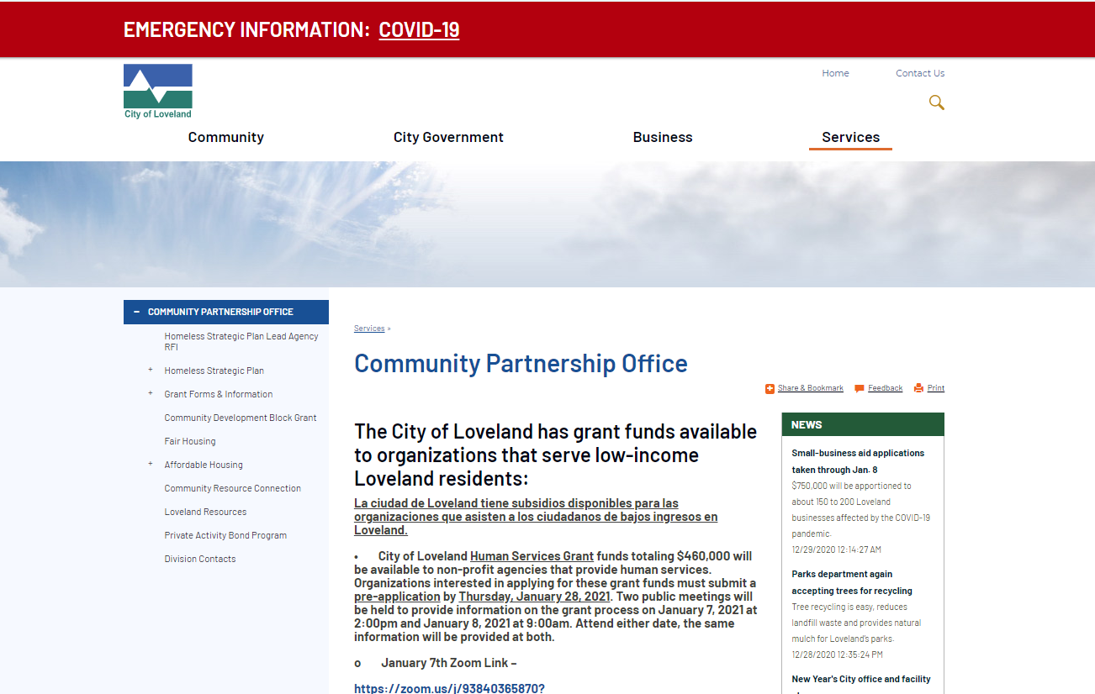
Click on Grants Forms and Information:

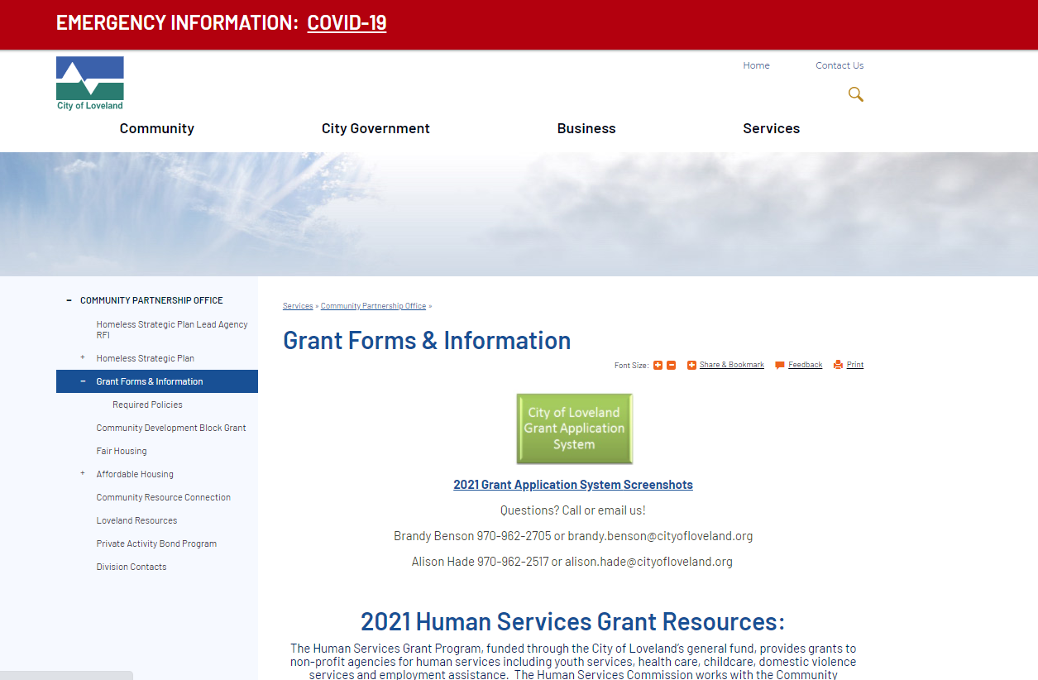Clicking the green button takes you to the grant management system.

Login or create new account. If you forgot your login, contact Brandy Benson
970-962-2705 or brandy.benson@cityofloveland.org:
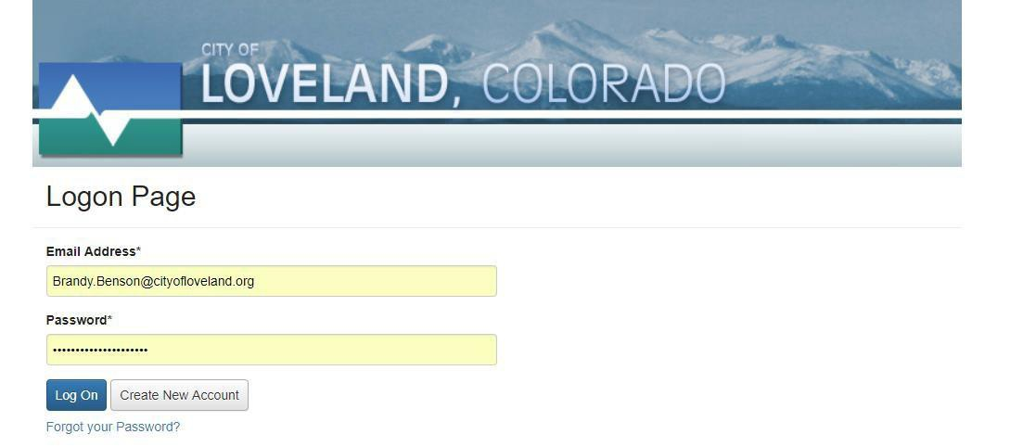

The House icon next to City of Loveland logo takes you to yourdashboard.
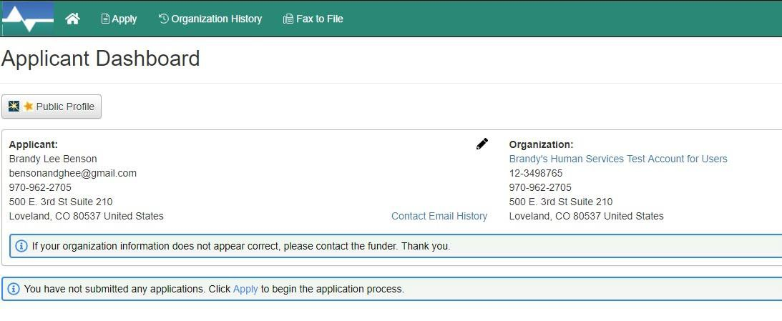

The Apply button next to house icon on top menu takes you to current or upcoming grant applications.
Scroll to select which grant program to apply for.
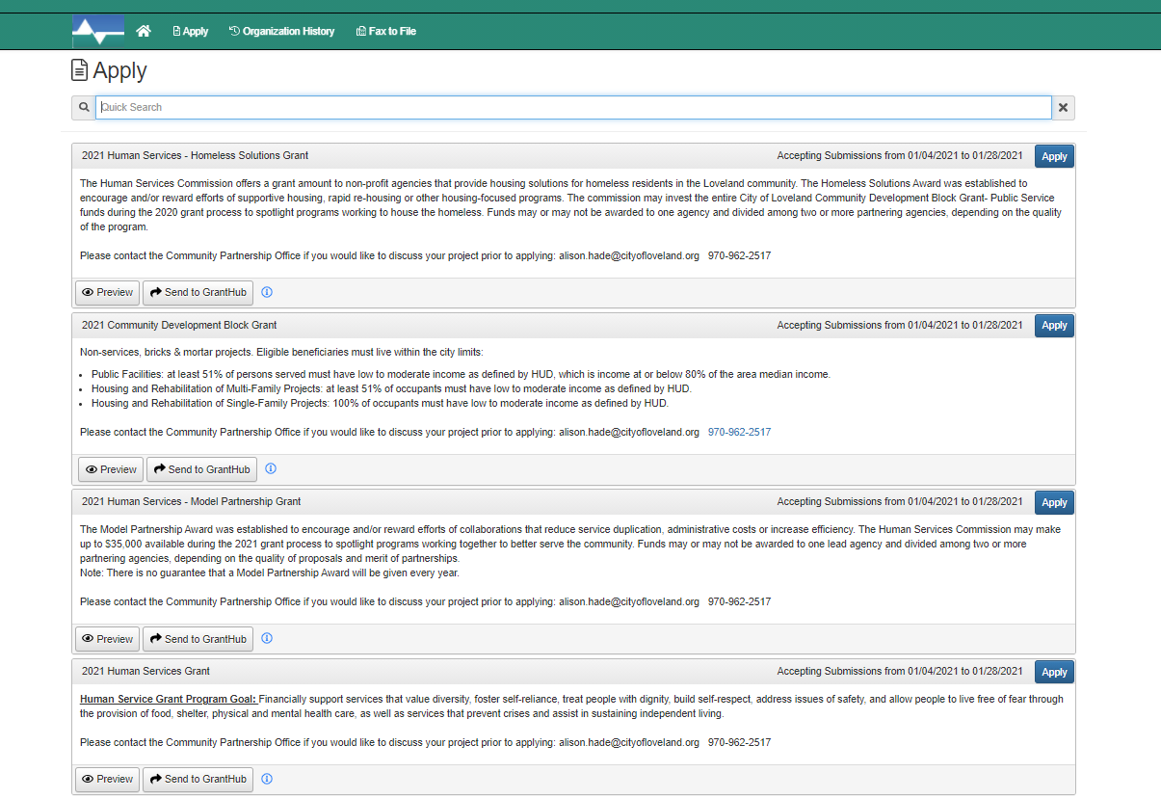

Pre-Applications= LOI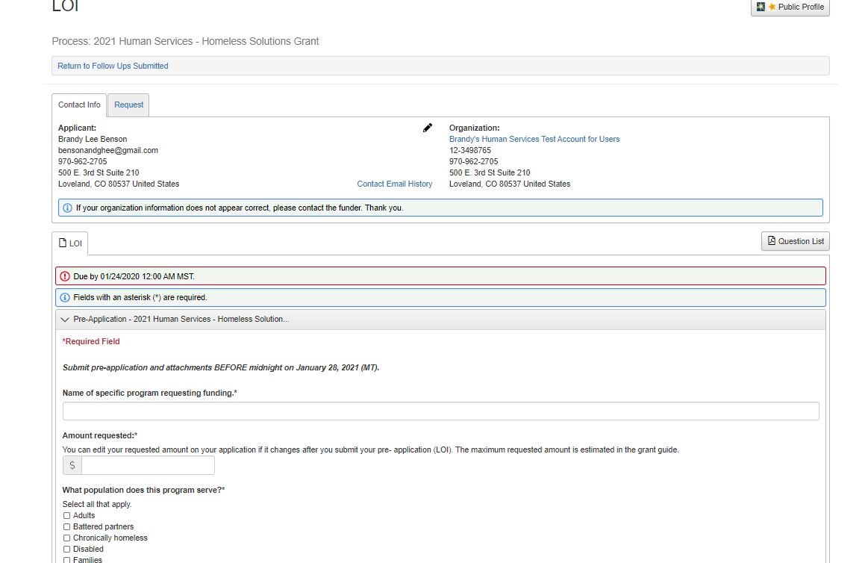

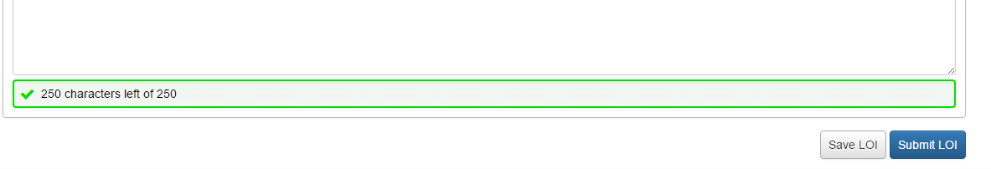

You must click submit prior to the midnight deadline in order to have your program considered. Technical difficulties with the system MAY NOT extend
the deadline. We recommend that you submit during business hours.

Once the Pre-Application= LOI is completed and marked complete by the Community Partnership Office the application form (Proposal) will be loaded into your online profile to begin working on it.

To See You Pre-Application (LOI) in PDF format click on Question Listc

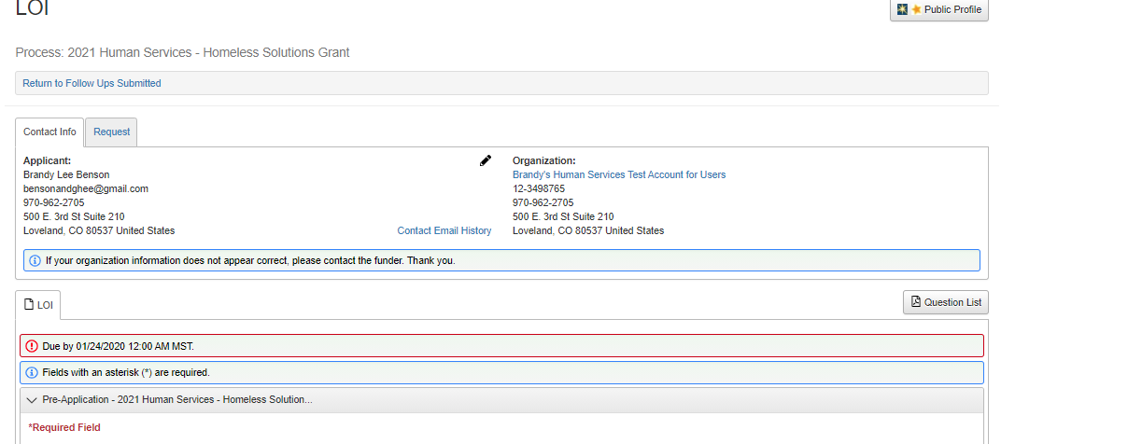

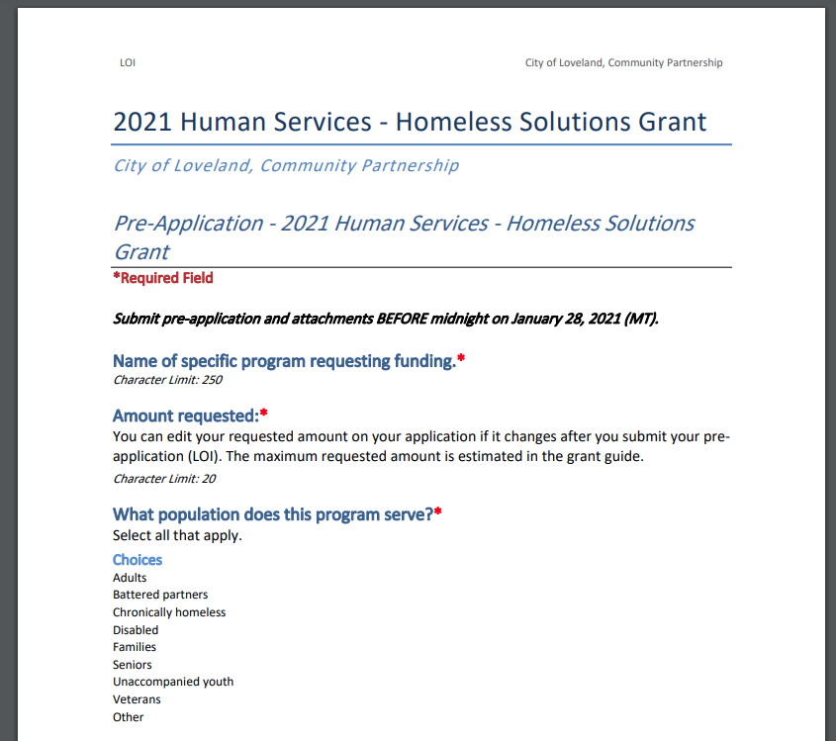

If you want to turn your document into a Word document and you have the
right Adobe software you can “save as” and select Word Document (*doc) as the type.This will convert the PDF to a Worddocument.
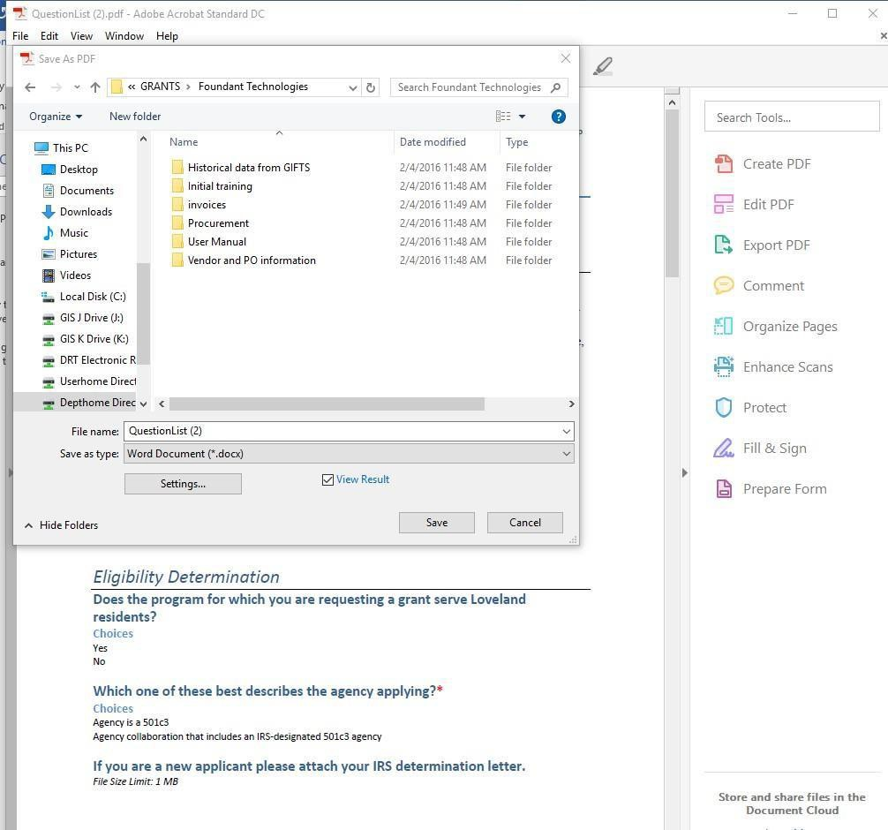

Fax to File Instructions:
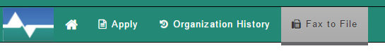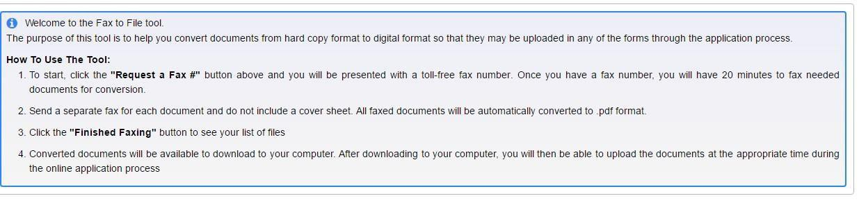

Organization Summary:
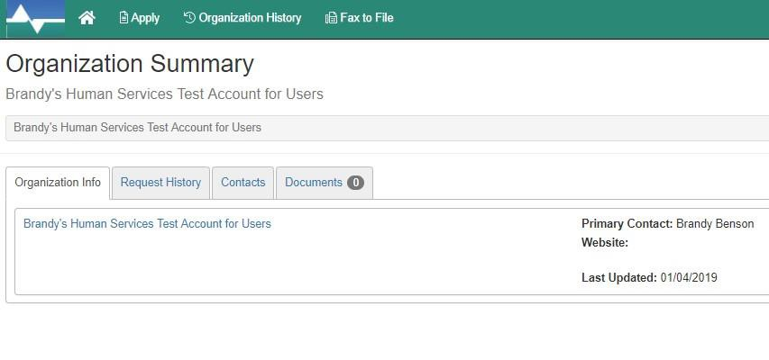

What to expect after LOI (pre-application) submission
- Email indicating you have submitted.
- Email indicating approval or denial of pre-application.
- If approved the application form (proposal) will be added to your account to begin working on.

What to expect after application (proposal) submitted
- Email indicating you have submitted.

Reminder- It is YOUR responsibility to keep email addresses and agency contacts updated in our system. We use the system to notify agencies and grant awardees/applicants of changes or opportunities through the Community Partnership Office.

IF AT ANY TIME YOU HAVE PROBLEMS WITH THIS SYSTEM OR HAVE QUESTIONS OR CONCERNED PLEASE DO NOT HESITATE TO CONTACT BRANDY BENSON.
970-962-2705 brandy.benson@cityofloveland.org

