Bridgewater Homes

Public Hearing Notice Letter

Date: June 26, 2020

Dear Property Owner:

This is a notice that a public hearing will be held to discuss the following proposal in your neighborhood.

Public Hearing Information
Public Hearing Board: | Zoning Board of Adjustment Hearing Officer
Application: | Variance
Project Case Number: | PZ-20-00098
Project Name: | 5128 Simla Drive Variance
Applicant Name: | James Miller – Bridgewater Homes
Meeting Date and Time: | July 13, 2020 at 4:00 pm
Meeting Location: | In an effort to prevent the spread of COVID-19 and comply with the Governor’s Executive Order for social distancing, the public hearing for this project will be conducted remotely. Please call the phone number listed below to participate in the meeting. If you have questions concerning participation or need additional assistance, please contact the Planning Office at 970-962-2523 prior to the hearing.
Meeting Phone Number | +1 253 215 8782 US  +1 301 715 8592 US
Meeting ID: | 974 8736 7807
Submittal of Information at the Hearing | Any written information that you intend to reference at the Zoning Board of Adjustment public hearing must be provided to the Planning Office by 9:00 a.m. on Friday July 10, 2020. This includes petitions, PowerPoint presentations, photos, letters, or other written information. Items submitted at the public hearing will not be accepted as they were not available for public review prior to the hearing. Please contact the Planning Office at 970-962-2523 for information on submitting written information.

Project Description
Summary of Variance Request: | Request to extend an attached garage past the front living portion of the home, exceeding the 10-foot requirement of the Unified Development Code.
General Location: | Within the Eagle Brook Meadows Subdivision, north of West 50th Street and west of North Taft Avenue
Property Address: | 5128 Simla Drive
Existing Zoning: | PUD - 72
Legal Description: | LOT 2, BLOCK 18, EAGLE BROOK MEADOWS 1ST SUB, LOV
Additional Information: | Additional information on the project is available at:  - www.CityofLoveland.org/CDA  - www.cityofloveland.org/departments/development-services/current-planning/neighborhood-notices-and-meetings.

Appeal Dates
Decision Date: | July 13, 2020.
Appeal Deadline: | July 27, 2020 at 4:30 pm is the last day to appeal the Zoning Board of Adjustment Hearing Officer’s decision.

Appeal Information
Purpose | The appeal procedures specified in Division 18.14.05 of the Loveland Municipal Code provides an opportunity for affected parties to seek review of a final decision of the Zoning Board of Adjustment Hearing Officer to ensure that the decision is correct.
Party Status | Appeals may be brought only by the following parties:  - An adjoining property owner; or  - A property owner who received this mailed notice and either participated in the public hearing or provided written comments to the Current Planning Division before the Hearing Officer’s decision.
Initiation of Appeal | An appeal of the Hearing Officer’s decision must be initiated by filing a petition on the form provided by the City and submitting the required fee to the Current Planning Division. The petition must contain all of the information specified in Section 18.14.05.04 of the Loveland Municipal Code. Please contact the Planning Office for information about submitting the petition and fee to the due to COVID-19 closure and furlough schedules.
Threshold Review | Once a petition is filed, the Director will confer with the City Attorney to ensure that the petitioner has party status, as described above, and there is sufficient detail in the petition to put the City on notice as to the legal basis of the appeal.  If the Director finds that the petitioner does not have party status or that the petition lacks the required information, the Director will deny the appeal, notify the petitioner, and return the submitted appeal fees.  If the Director finds that the petitioner has party status and the petition includes the required level of specificity, the Director will notify the petitioner of the acceptance, place the item on the agenda for the full Zoning Board of Adjustment, and notify the petitioner that the petitioner must provide mailed notice as specified in the Loveland Municipal Code.
Standards for Review | The scope of the appellate review is limited to the issues raised in the petition. Issues that are not described or obviously implied by the petition will not be considered. New evidence cannot be introduced on appeal.
Zoning Board of Adjustment | After review of the record and arguments advanced on appeal, the Zoning Board of Adjustment will determine whether the Hearing Officer’s decision was correct based on the applicable Code provisions. The Zoning Board of Adjustment’s decision represents the final decision by the City.

If you have any questions regarding the proposed project, please contact: James Miller, 251-747-8839, james@bridgewaterhomes.com . If you have questions regarding the City process, please contact Emily Tarantini, Emily.Tarantini@cityofloveland.org, 970-962-2581.

Sincerely,
James C. Miller
Bridgewater Homes

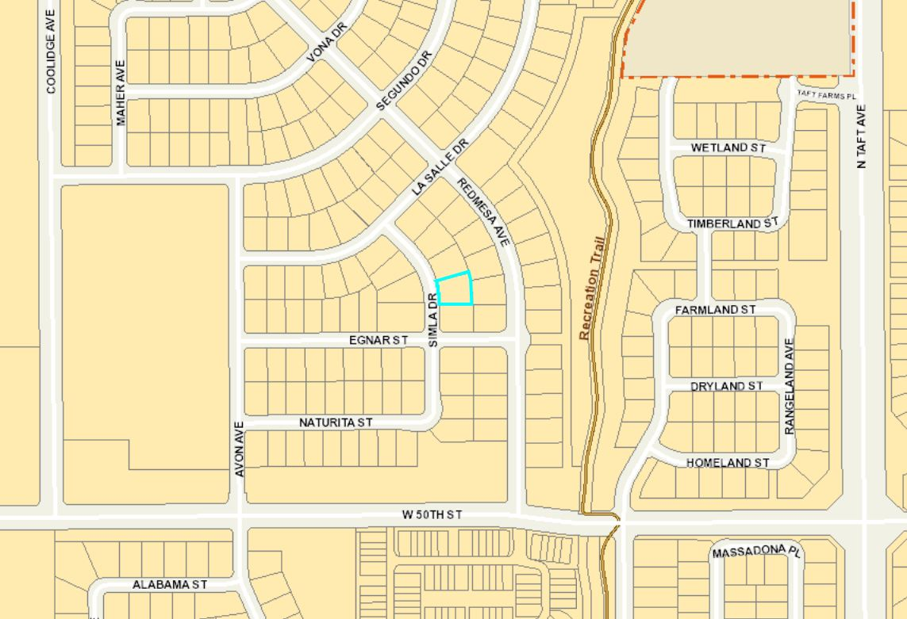
Subject property

