CR-05 - Goals and Outcomes
Progress the jurisdiction has made in carrying out its strategic plan and its action plan. 91.520(a)
This could be an overview that includes major initiatives and highlights that were proposed and executed throughout the program year.

During the third year of the 2015-2020 Consolidated Plan, the City of Loveland expected to complete at least 20% of the 5-year goals. By the end of the program year, the goal of new single-family housing, public services and rehabilitation of public facilities have been met in full. The rehabilitation of single family housing goal is on track to be completed by the end of the five years. The goals of new multi-family housing, housing for homeless residents and rehabilitation of multi-family housing will likely not be met by the end of the Consolidated Plan, although progress has been made that has significantly improved the lives of many Loveland residents.
Most of the goals were completed using City of Loveland Community Development Block Grant (CDBG) funding. Other City of Loveland funding was used to complete the new single family housing goals with 76 new units built over the last three years. That funding and those projects are not recorded in IDIS.

Comparison of the proposed versus actual outcomes for each outcome measure submitted with the consolidated plan and explain, if applicable, why progress was not made toward meeting goals and objectives. 91.520(g)
Categories, priority levels, funding sources and amounts, outcomes/objectives, goal outcome indicators, units of measure, targets, actual outcomes/outputs, and percentage completed for each of the grantee’s program year goals.

Goal | Category | Source / Amount | Indicator | Unit of Measure | Expected – Strategic Plan | Actual – Strategic Plan | Percent Complete | Expected – Program Year | Actual – Program Year | Percent Complete
Table 1 - Accomplishments – Program Year & Strategic Plan to Date

Assess how the jurisdiction’s use of funds, particularly CDBG, addresses the priorities and specific objectives identified in the plan, giving special attention to the highest priority activities identified.
The highest priority for City of Loveland CDBG funding is building new affordable single or multi-family housing, or new housing for the homeless. A request for funding from the Loveland Housing Authority to build 60 units of senior housing received a 9% Low Income Housing Tax Credit award in 2018 and will be built in 2019. That project will receive $285,885 in CDBG. Additional housing for homeless residents may be built in the future, after the City of Loveland completes a Homeless Strategic Plan in 2019.
The second priority is rehabilitating housing to ensure residents are able to remain in their homes. 131 units were rehabilitated during the grant year, which meets the result for single-family homes but does not meet the objective for multi-family homes.
The third priority is to provide a public service. During the program year, 6,487 residents accessed services from three agencies: 237 survivors of domestic violence received shelter from the Loveland Safe House, 273 homeless residents received services from the Murphy Center day center, and 5,977 residents received food from House of Neighborly Service.
The last priority is to invest in public facilities. One project wil be completed by the end of the calendar year. This objective was met in 2017.

CR-10 - Racial and Ethnic composition of families assisted
Describe the families assisted (including the racial and ethnic status of families assisted). 91.520(a)

Table 2 – Table of assistance to racial and ethnic populations by source of funds

Narrative
Attached data shows a comparison of sub-recipient race/ethnicity data compared to Loveland using American Fact Finder 5-year data (2011-2015) and information from the point-in-time homeless count. City of Loveland sub-recipients served fewer White, Asian, American Indian/White, African American & White and Multi-racial clients, but more Hispanic, Black, Native Alaskan, Pacific Island, American India/Black and Asian/White.

CR-15 - Resources and Investments 91.520(a)
Identify the resources made available
Source of Funds | Source | Resources Made Available | Amount Expended During Program Year
CDBG | CDBG | 316,186 | 474,236
HOME | HOME
HOPWA | HOPWA
ESG | ESG
Other | Other
Table 3 - Resources Made Available

Narrative
The City of Loveland received a 2017-2018 CDBG award of $316,186 and had funding remaining from years. Program income of $44,401.23 that had been granted was returned to the Treasury for a total of $300,887. Since the beginning of the program year, $226,850 has been used to fund projects with $74,037 remaining. That balance will be combined with 2018-2019 program year funding and will be spent within the next six months.

Identify the geographic distribution and location of investments
Target Area | Planned Percentage of Allocation | Actual Percentage of Allocation | Narrative Description
Table 4 – Identify the geographic distribution and location of investments

Narrative
The City of Loveland does not distribute grant funding based on a Target Area. Instead, all funding is used for housing or services for residents living at or below 80% of the Area Median Income.

Leveraging
Explain how federal funds leveraged additional resources (private, state and local funds), including a description of how matching requirements were satisfied, as well as how any publicly owned land or property located within the jurisdiction that were used to address the needs identified in the plan.
The City of Loveland completed and closed projects totalling $404,719 during the program year. Funding leveraged by completed projects was $1.67 million (see attached spreadsheet).

CR-20 - Affordable Housing 91.520(b)
Evaluation of the jurisdiction's progress in providing affordable housing, including the number and types of families served, the number of extremely low-income, low-income, moderate-income, and middle-income persons served.

 | One-Year Goal | Actual
Number of Homeless households to be provided affordable housing units | 5 | 0
Number of Non-Homeless households to be provided affordable housing units | 75 | 37
Number of Special-Needs households to be provided affordable housing units | 0 | 0
Total | 80 | 37
Table 11 – Number of Households

 | One-Year Goal | Actual
Number of households supported through Rental Assistance | 0 | 0
Number of households supported through The Production of New Units | 80 | 0
Number of households supported through Rehab of Existing Units | 160 | 207
Number of households supported through Acquisition of Existing Units | 0 | 0
Total | 240 | 207
Table 12 – Number of Households Supported

Discuss the difference between goals and outcomes and problems encountered in meeting these goals.
The City of Loveland hopes to complete 30 units of new housing for homeless residents over the five years of the Consolidated Plan but has produced none so far. Also expected over five years are 75 units of new single-family housing and 300 units of new multi-family housing. Thirty-seven units of new single-family housing was completed and is listed above even though the units were not funded with CDBG. Altogether, the City of Loveland expected to create 80 new units of housing.
One hundred sixty (160) units of housing was expected to be rehabilitated, or 1/5th of 800 units.

Discuss how these outcomes will impact future annual action plans.
The City of Loveland likely has better tools to predict new and rehabilitated housing that will occur between 2020 and 2025, making the predicted outcomes more reliable.

Include the number of extremely low-income, low-income, and moderate-income persons served by each activity where information on income by family size is required to determine the eligibility of the activity.

Table 13 – Number of Households Served

Narrative Information

CR-25 - Homeless and Other Special Needs 91.220(d, e); 91.320(d, e); 91.520(c)
Evaluate the jurisdiction’s progress in meeting its specific objectives for reducing and ending homelessness through:
Reaching out to homeless persons (especially unsheltered persons) and assessing their individual needs
Reaching out to homeless persons was accomplished during the annual point-in-time homeless count and Loveland Connect event, and by volunteering to serve lunch at the Community Kitchen. The Community Partnership Office participated in all three activities resulting in meeting many homeless, providing a direct service as requested and adding people to our regional Coordinated Entry by-name-list.

Addressing the emergency shelter and transitional housing needs of homeless persons
The City of Loveland currently provides direct funding for two homeless programs working with adults and families. The family program provides year-around shelter in local churches and the individual program provides shelter when the night temperature drops to 20 degrees from November through March. The number of transitional housing beds in Loveland has not increased for many years.
The City of Loveland is now working on a Housing First model and will not be pursuing additional non-permanent housing or additional shelter beds using CDBG.

Helping low-income individuals and families avoid becoming homeless, especially extremely low-income individuals and families and those who are: likely to become homeless after being discharged from publicly funded institutions and systems of care (such as health care facilities, mental health facilities, foster care and other youth facilities, and corrections programs and institutions); and, receiving assistance from public or private agencies that address housing, health, social services, employment, education, or youth needs
The City of Loveland funds Volunteers of America and the Loveland Housing Authority, both of which work to keep people housed through home rehabilitation. The City of Loveland also funds agencies that provide rental assistance (Neighbor to Neighbor) or housing (Alternatives to Violence, House of Neighborly Service, SummitStone Health Partners, Disabled Resource Services, Matthews House), although not always with CDBG public service funding. Other community partners working to keep people housed include the Salvation Army and SummitStone Health Partners. The Community Partnership Office does not work with publicly funded institutions and systems of care to help people from becoming homeless after they have been discharged.

Helping homeless persons (especially chronically homeless individuals and families, families with children, veterans and their families, and unaccompanied youth) make the transition to permanent housing and independent living, including shortening the period of time that individuals and families experience homelessness, facilitating access for homeless individuals and families to affordable housing units, and preventing individuals and families who were recently homeless from becoming homeless again
The Community Partnership Office staff have been working with regional partners on Coordinated Entry. Over the last three years, northern Colorado partners have housed 72.16% of all homeless veterans (254 people), 21.46% of non-veteran adults (75 people), and 48.6% of families (46 families).
The City of Loveland recently hired a consultant group from the Burnes Center on Poverty & Homelessness to complete a Homeless Strategic Plan. Should a need be shown, Loveland may invest in additional permanent supportive housing.

CR-30 - Public Housing 91.220(h); 91.320(j)
Actions taken to address the needs of public housing
The City of Loveland addresses public housing needs by allocating grant and other funding to organizations that provide housing. In 2018, the City of Loveland agreed to $1.25 million to the Loveland Housing Authority for 60 units of senior housing ($285,885 in CDBG, $967,791 in fee waivers), $167,895 to Habitat for Humanity for permit/development fees on six homes, and $257,414 to Loveland Housing Authority for permit/development fees on 30 units of skilled nursing.
The City of Loveland also provided funding for housing rehabilitation. The Loveland Housing Authority received $70,200 for emergency home repair grants and low interest loans, and Volunteers of America will receive $25,000 to make the homes of seniors and residents with disabilities more accessible. Loveland Housing Authority will receive a waiver of permit fees totaling $97,575 to rehabilitate 60 units of low income housing.

Actions taken to encourage public housing residents to become more involved in management and participate in homeownership
The Loveland Housing Authority Resident Advisory Board, comprised of residents from each of the housing properties in Loveland, works directly with Housing Authority staff and not the City of Loveland. Therefore, any actions to encourage housing residents to be more involved and to support them in homeownership falls under the leadership of the Loveland Housing Authority.
In 2017 and 2018, a new staff member of the Loveland Housing Authority convened a group of local stakeholders to discuss a new Resident Initiatives Project to connect Housing Authority residents to resources and opportunities to increase self-sufficiency and greater health outcomes. Areas for success include improving access to education, health and wellness activities, and other support for low income households to maintain their affordable housing. The result of the meetings was a new non-profit organization within the Housing Authority that will address housing stability by providing programs for youth and support for families, services to keep veterans housed, and navigation services to improve access to health and wellness for older adults.

Actions taken to provide assistance to troubled PHAs
The Loveland Housing Authority is not designated as troubled.

CR-35 - Other Actions 91.220(j)-(k); 91.320(i)-(j)
Actions taken to remove or ameliorate the negative effects of public policies that serve as barriers to affordable housing such as land use controls, tax policies affecting land, zoning ordinances, building codes, fees and charges, growth limitations, and policies affecting the return on residential investment. 91.220 (j); 91.320 (i)
The City's strategy to remove barriers and provide incentives to developers and builders of affordable housing include use tax credits and the waiver or reduction of development fees, capital expansion and building permit fees. The City of Loveland adopted an affordable housing code to encourage the building of low-income housing in 1994 and updated incentives for single-family and multi-housing projects in 2017. As stated, Loveland City Council waived $167,895 for six new homes built by Habitat for Humanity, $967,791 for 60 units of multi-family senior housing and $257,414 for 30 skilled nursing beds. In 2017, the Loveland City Council voted to provide 1.25% of sales tax revenue annually for affordable housing, most of which will be used for the waiver of fees for Habitat for Humanity and the Loveland Housing Authority. Over the past ten years, Loveland’s affordable housing policy has resulted in an investment of more than $9 million dollars of City incentives in addition to CDBG funding, and has resulted in about 800 units of housing.
In 2016, the City of Loveland office of Strategic Planning completed the City of Loveland 10-year Comprehensive Plan and just completed re-writing the zoning code to compliment. Included in the new code is a streamline process for new development and the ability to build homes as small as 400 square feet with minimal set backs and a reduction in parking. The new Unified Development Code will take effect on January 1, 2019.

Actions taken to address obstacles to meeting underserved needs. 91.220(k); 91.320(j)
The Community Partnership Office held the seventh annual Loveland Homeless Connect event on October 12, 2018. 275 homeless and near homeless residents received information about housing and other social services, direct health and dental care, pet services, a hair cut, and two meals provided by 50 service agencies.
Communtiy Partnership Office staff has continued to discuss program accessibility with funded agencies, including the manner in which the working poor access services that are generally only available during regular business hours. The Human Services and Affordable Housing Commissions continue to discuss program improvement during the annual grant process to better understand the experience of non-profit customers. In 2018, the Community Partnership Office contracted with an organization to assist with the process of bridging the gap between funding and services and will assist organizations with mandatory policies, including a customer grievance policy and procedure.

Actions taken to reduce lead-based paint hazards. 91.220(k); 91.320(j)
The Community Partnership Office requires that all activities funded with CDBG dollars comply with federal regulations concerning lead-based paint.

Actions taken to reduce the number of poverty-level families. 91.220(k); 91.320(j)
The City of Loveland allocates $500,000 in grant funding to services organizations in addition to CDBG public service dollars. All funded agencies work with low to moderate income individuals with most individuals living at or below the poverty line.
The Community Partnership Office will work to connect anyone who calls the office to local resources and has kept several people housed through advocacy.

Actions taken to develop institutional structure. 91.220(k); 91.320(j)
The Community Partnership Office continues to participate in the Northern Colorado Continuum of Care on Coordinated Entry, also known as the Coordinated Assessment and Housing Placement System (CAHPS), to match people who need housing with housing providers. The community partners working on the system engaged in the Action Lab training provided by the Governor’s Office in 2016 and to date have housed 329 individuals and 46 families in Larimer and Weld County.

Actions taken to enhance coordination between public and private housing and social service agencies. 91.220(k); 91.320(j)
The Community Partnership Office works to ensure that funded services are accessible to the residents who need them. To that end, the office started a monthly meeting to have agency representatives share their program information with other agencies. Questions asked are the type of identification needed for services, hours of operation, and whether the agency serves undocumented individuals. The goal of the meetings is to ensure that organizations provide a warm hand-off to another agency versus providing a referral. Both housing and service agencies participate in these meetings.

Identify actions taken to overcome the effects of any impediments identified in the jurisdictions analysis of impediments to fair housing choice. 91.520(a)
The City of Loveland completed an Assessment of Fair Housing in 2018. Actions described in the document and actions taken since the document was submitted are as follows:
- New Fair Housing posters were distributed to CDBG sub-recipients and other relevant agencies during monitoring visits. A sticker on the poster (in English and Spanish) gives customers additional information about how to file a complaint or discuss fair housing with a local contact to potentially make assistance easier.
- A Fair Housing month proclamation is presented by city council each year on the first Tuesday of April. A Fair Housing month advertisement is placed in the utility bill in April and mailed to about 39,000 residents. The ad provides information about who to call with a complaint or to talk about housing issues. The Community Partnership Office received very few calls in 2018.
- Information about public meetings was advertised in English and Spanish and meetings were held in accessible locations. Agendas include information about accessing assistance for other needs under Title VI and the Americans with Disabilities Act. An assistive hearing device is now always available at monthly Human Service Commission meetings.
- Loveland resident housing complaints are discussed with the Office of Fair Housing. In 2018, the Community Partnership Office called HUD several times about a complaint a resident had with her HOA. When that resident received a final report from the Department of Regulatory Agencies, she did not feel that her case was actually heard. The Community Partnership Office continued to advocate with FHEO on her behalf.
- The Community Partnership Office has been working with federal and non-federally funded non-profits to ensure their Title VI and Americans with Disabilities policies are in compliance. This work is expected to continue for the next several years but progress was made in 2018. In 2019, a stipulation will be put in contracts giving a finite amount of time to finish this work.
- The Affordable Housing Commission asks questions about proximity to food and transportation when making decisions about granting fee waivers for new housing projects.
- The new Unified Development Code will allow developers to create significantly smaller homes on appropriately sized lots. This update to the City of Loveland zoning code will hopefully allow more housing options for residents.
- The City of Loveland Public Works Department has been working on new public tranportation routes to increase options for bus service end users.

CR-40 - Monitoring 91.220 and 91.230
Describe the standards and procedures used to monitor activities carried out in furtherance of the plan and used to ensure long-term compliance with requirements of the programs involved, including minority business outreach and the comprehensive planning requirements
The Community Partnership Office strives to complete monitoring of all projects within six months of project completion and is almost up-to-date with that result.
As stated, the Community Partnership Office has been working with federally funded and non-federaly funded agencies to ensure their Title VI and Americans with Disabilities policies are complete. This is another large monitoring project that is expected to take some time.

Citizen Participation Plan 91.105(d); 91.115(d)
Describe the efforts to provide citizens with reasonable notice and an opportunity to comment on performance reports.
The City of Loveland allows 15 days for citizens to comment on year-end performance reports. Information is placed in the local newspaper and facebook. A hard-copy of the year-end report is availble in hard-copy and large print.

CR-45 - CDBG 91.520(c)
Specify the nature of, and reasons for, any changes in the jurisdiction’s program objectives and indications of how the jurisdiction would change its programs as a result of its experiences.
Program objectives have not been changed since the Consolidated Plan was submitted in 2015.

Does this Jurisdiction have any open Brownfields Economic Development Initiative (BEDI) grants?
No
[BEDI grantees] Describe accomplishments and program outcomes during the last year.

CR-45 - CDBG 91.520(c)
Specify the nature of, and reasons for, any changes in the jurisdiction’s program objectives and indications of how the jurisdiction would change its programs as a result of its experiences.
Program objectives have not been changed since the Consolidated Plan was submitted in 2015.

Does this Jurisdiction have any open Brownfields Economic Development Initiative (BEDI) grants?
No
[BEDI grantees] Describe accomplishments and program outcomes during the last year.

Attachment
Cover Page
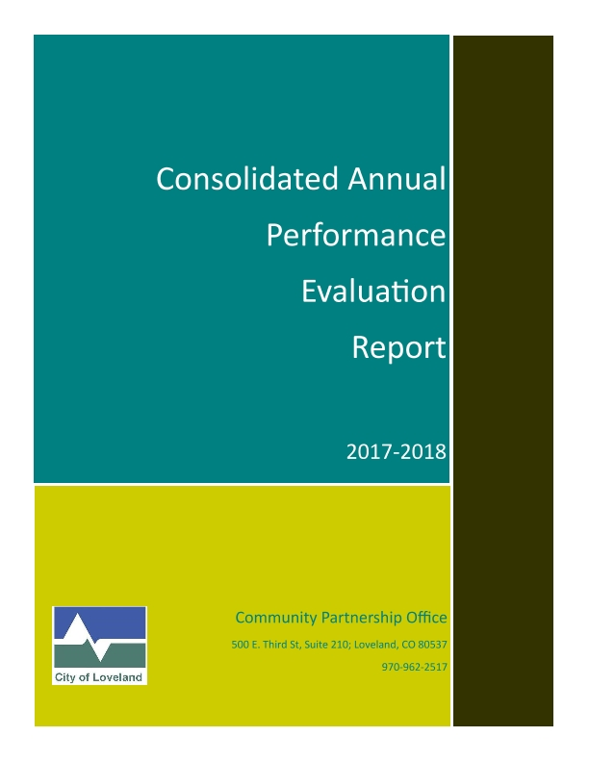

Executive Summary
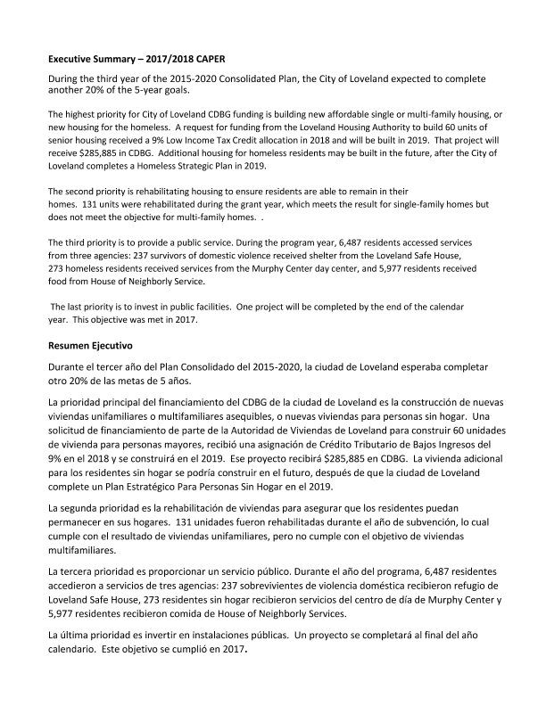

FHEO Supplemental ÿ Leveraging
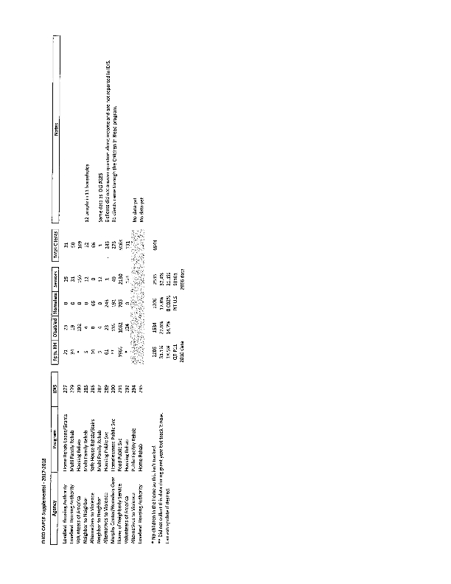
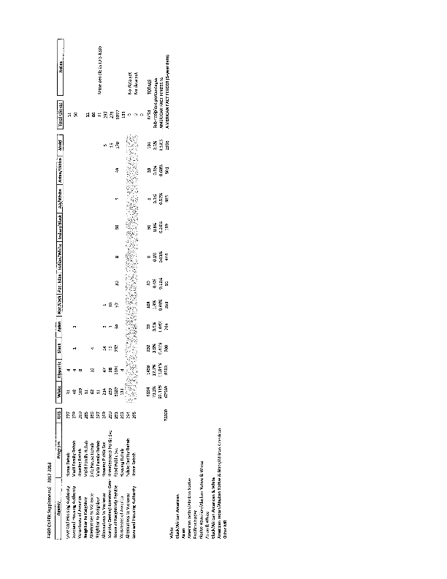
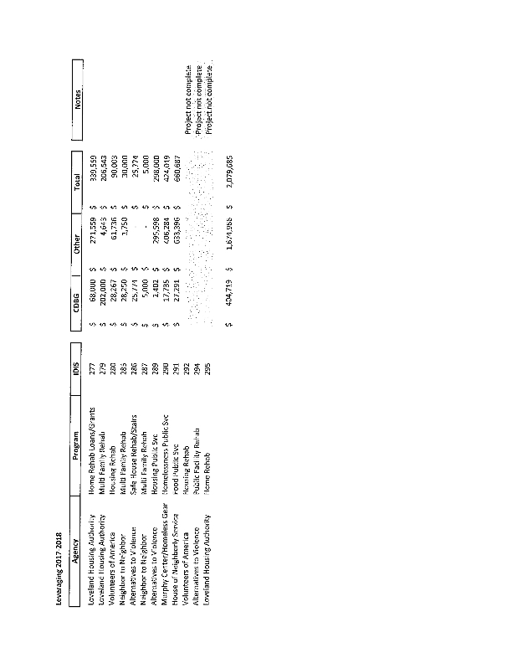

PR26
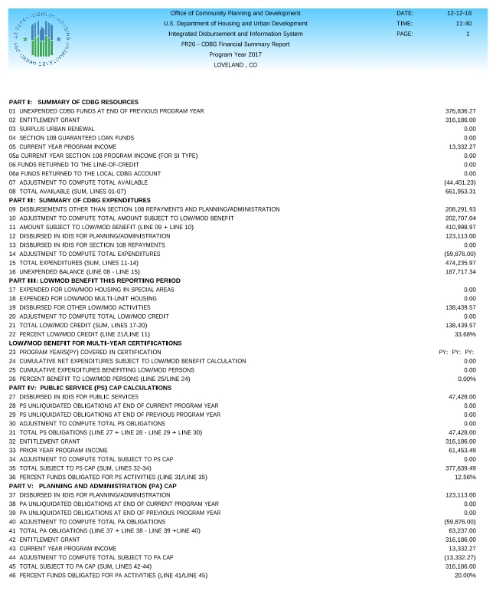
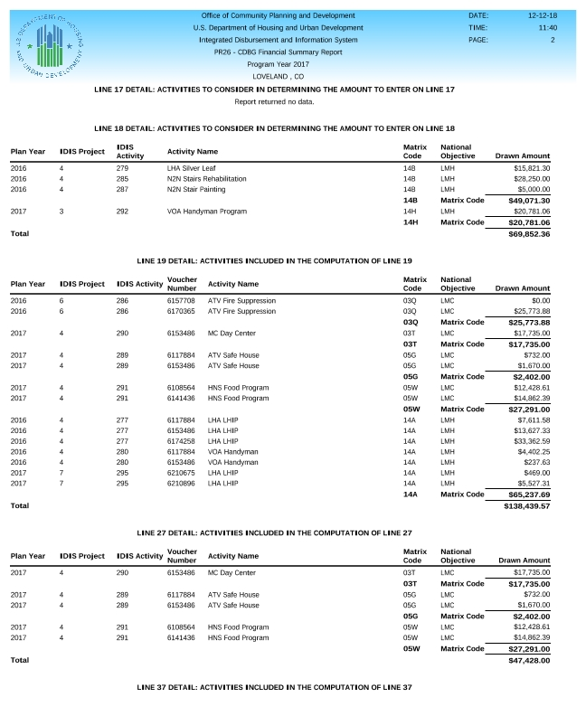
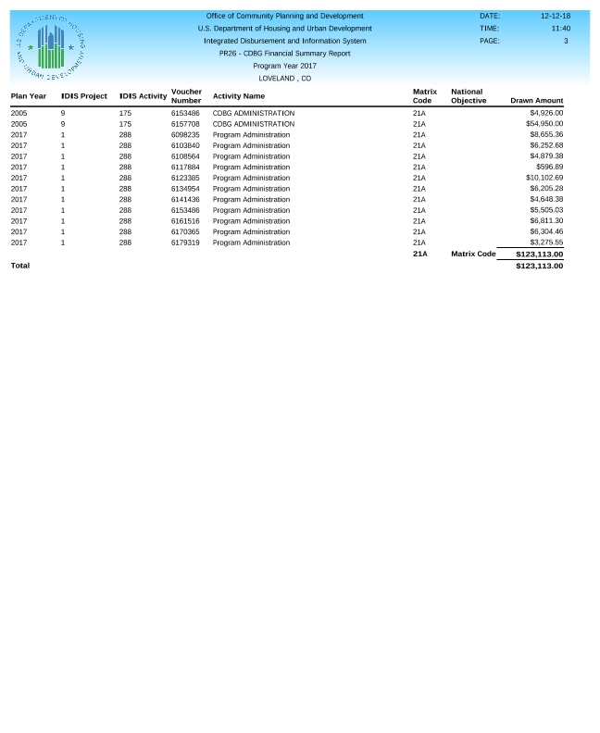

Newspaper Ad
