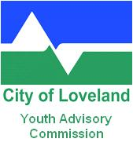
LOVELAND YOUTH ADVISORY COMMISSION MEETING
May 1, 2019
5:00 pm – 6:30 pm
Loveland Public Library

The City of Loveland is committed to providing an equal opportunity for citizens and does not discriminate on the basis of disability, race, color, national origin, religion, sexual orientation or gender. The City will make reasonable accommodations for citizens in accordance with the Americans with Disabilities Act. For more information, please contact the City’s ADA Coordinator at bettie.greenberg@cityofloveland.org or 970-962-3319.

MEETING RESCHEDULING NOTICE

The Youth Advisory Commission has canceled their May 1, 2019 meeting. The meeting has been rescheduled for Wednesday, May 8, 2019 for 5:00 pm at the Loveland Public Library.

For more information, please contact the Staff Liaison, Beth Gudmestad at 970-962-2448.

