FINAL FINDINGS REPORT
950 E Eisenhower Blvd Special Review #947 (PZ #18-00079)
July 18, 2018

TITLE: Loveland East Farmers’ Market – Special Review #947

LOCATION: 950 E Eisenhower Blvd

APPLICANT: Nan Zimmerman

STAFF CONTACT: Caleb Jackson, Current Planning
Melissa Morin, Water/Wastewater
Suzette Schaff, Stormwater
Mark Warner, Power
Randy Maizland, Transportation Dev. Review
Ingrid McMillan-Ernst, Fire

APPLICATION TYPE: Special Review #947

STAFF RECOMMENDATION: Staff recommends that the Current Planning Manager approve a Type 2 Zoning Permit at 950 E Eisenhower Blvd for an open-air farmers market as described in this report dated July 18, 2018.

I. ATTACHMENTS
1. Vicinity Map
2. Site Plan

II. SITE DATA

EXISTING USE Parking lot, retail & fitness facility
PROPOSED USE Open-air farmers market (Approximately 6700 sqft.)
EXISTING ZONING B– Developing Business
EXISTING ADJACENT ZONING & USE- North B– Developing Business, Mixed Commercial Uses
EXISTING ADJACENT ZONING & USE – East B– Developing Business, Retail Use
EXISTING ADJACENT ZONING & USE- South I–Developing Industrial, Mixed Commercial/Industrial Uses
EXISTING ADJACENT ZONING & USE - West B– Developing Business, Vacant Use
UTILITY SERVICE – WATER City of Loveland
UTILITY SERVICE – SEWER City of Loveland
UTILITY SERVICE – ELECTRIC City of Loveland

III. PROJECT DESCRIPTION

The applicant is proposing to operate an open-air farmers market on Tuesdays from 3:00 PM to 6:00 PM, in approximately 6700 square feet of the existing parking lot at 950 E Eisenhower Blvd. The property is zoned B-Developing Business, and the use of an open-air farmers market is permitted only through the approval of a special review. The special review includes a neighborhood meeting, a comment period, and an appeal period.

IV. KEY ISSUES

The primary issue initially identified by staff is that the proposal results in inadequate parking according the code’s base standards; however, the site offers adequate parking during the proposed hours of operation based on actual observations. Furthermore, nobody attended the neighborhood or contacted staff to express concerns with the proposal.

V. BACKGROUND

The zoning on the property is B-Developing Business.
In 1993, a retail store was constructed on-site. Today, that building is 97,318 square feet.
In 2006, a fitness facility was approved to occupy 38,449 square feet of the existing building with a 4351 square foot unfinished mezzanine.

VI. STAFF, APPLICANT, AND NEIGHBORHOOD INTERACTION

A. Notification
A letter advertising the neighborhood meeting was sent out on June 11, 2018, to all neighbors within the “Neighborhood” as defined in Section 18.40.010.C of the Loveland Municipal Code. A meeting notice sign was posted on the property on June 11, 2018.

B. Neighborhood Response
A neighborhood meeting was held on June 26, 2018, regarding this project. The applicant and City staff were in attendance; however, no members of the neighborhood attended the meeting.

C. Project Schedule
1. Special Review #947 was filed with the Current Planning Department on May 30, 2018.

2. A neighborhood meeting was held on June 26, 2018, at 6:30 p.m. at 950 E Eisenhower Blvd.

3. The staff preliminary findings and determination were posted on July 6, 2018.

4. The public review period for the staff preliminary findings and determinations was from July 6, 2018 to July 17, 2018. No public comments were submitted.

5. Final findings and determination were issued on July 18, 2018.

5. The appeal period for the Type 2 Zoning Permit for Special Review #947 is from July 18, 2018 to July 27, 2018.

VII. FINDINGS AND ANALYSIS

Finding 1. That the proposed special review use meets the purposes set forth in Section 18.04.010 of the Loveland Municipal Code.

The proposed development of an open-air farmers market would meet the purposes of Section 18.04.010 of the Loveland Municipal Code, by not creating unsafe or unhealthy conditions and by providing adequate facilities (i.e. transportation, water, sewer, power, etc.), appropriate use of land, and keeping with the character of the land.

Finding 2. That the effects of the proposed special review use on the surrounding neighborhood and the public in general will be ameliorated.

The proposed special review use is consistent with the surrounding neighborhood in that it fits into the shopping center by offering an additional commercial option without resulting in deficient parking based on actual observations.

Finding 3. That in assessing the potential effects of the proposed special review use, at a minimum, the following matters have been considered:

3a. Type, size, amount, and placement of landscaping;
Existing landscaping for the existing commercial center is to remain unchanged.

3b. Height, size, placement, and number of signs;
Signage is not approved with the special review; however, the applicant has submitted an application for temporary signs that is reviewed and approved separately.

3c. Use, location, number, height, size, architectural design, materials, and colors of buildings;
The only new structures are small, temporary canopies for vendors of a size not requiring permit.

3d. Configuration and placement of vehicular and pedestrian access and circulation;
The proposed location allows vehicular and pedestrian circulation to continue unchanged throughout the site. A traffic worksheet was provided and demonstrates that the existing transportation system can adequately serve the proposal. Fire has determined that the proposed market will not negatively impact fire protection for the subject development or surrounding properties.

3e. Amount and configuration of parking;
Sufficient on-site parking is available based on actual observations. Observed open parking spaces the week prior to operation of the open-air farmers market showed 181 available spaces at 4:00 PM, 132 at 5:00 PM, and 168 at 6:00 PM. During a subsequent week while the market operated, 120 spaces were open at 4:00 PM, 102 at 5:00 PM, and 117 at 6:00 PM.

3f. Amount, placement, and intensity of lighting;
No new lighting is proposed. Current site lighting will remain unchanged.

3g. Hours of operation;
The open-air farmers market will be limited to Tuesdays from 3:00 PM to 6:00 PM. The market area must be clean and returned to unobstructed parking by 7:00 PM.

3h. Emissions of noise, dust, fumes, glare, and other pollutants.
Noise, dust, fumes, glare, and other pollutants are not anticipated.

Finding 4. Except as may be varied in accordance with this special review permit, the special review site plan conforms to the restrictions and regulations set forth in the Loveland Municipal Code for the zoning district in which the special review use is located.

The proposed special review meets this finding. The proposed use will make use of what is now and underutilized parking lot. This design proposal is compatible with the surrounding area.

Finding 5. The special review site plan meets the requirements set forth in Section 16. 41 - Adequate Community Services - of the Loveland Municipal Code.

Transportation: Staff believes that this finding can be met due to the following:
- A traffic worksheet was provided showing that the site meets the applicable standards.
Fire: Staff believes that this finding can be met, due to the following:
- The development site will comply with the requirements in the ACF Ordinance for response distance requirements from the first due Engine Company.
- The proposed farmers market location will not negatively impact fire protection for the subject development or surrounding properties.
Water/Wastewater: Staff believes that this finding can be met, due to the following:
- The proposed open air market (Farmer’s Market) is proposed to be situated within the existing asphalt parking area. The open air market is not proposing any water or wastewater use. The site is located within the City’s current service area for both water and wastewater. The Department finds that the Development will be compliant to ACF for the following reasons:
The proposed development will not negatively impact City water and wastewater facilities.

Stormwater: Staff believes that this finding can be met, due to the following:
- This special review site plan complies with the Adequate Community Facilities standards set forth in the Loveland Municipal Code, Section 16.41.140.special review site plan and the site development plan comply with the Adequate Community Facilities standards set forth in the Loveland Municipal Code, Section 16.41.140.

Power: Staff believes that this finding can be met, due to the following:
- No power required.

Attachment 1: Vicinity Map

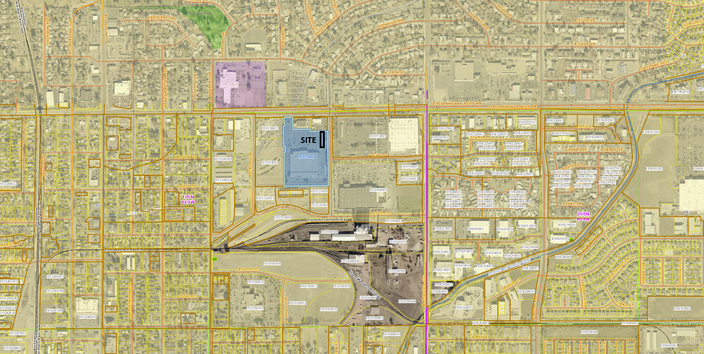

Attachment 2: Site Plan
