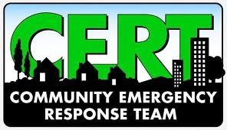
Be prepared…Join CERT
FREE training June 13-14, 21

Call Chris Wolf 970-416-2859

http://www.poudre-fire.org/emergency-preparedness

