Citizen Access – Public Access for Code Enforcement Cases

From the City’s Internet site: the URL : https://wsinno.ci.loveland.co.us/citizenaccess/

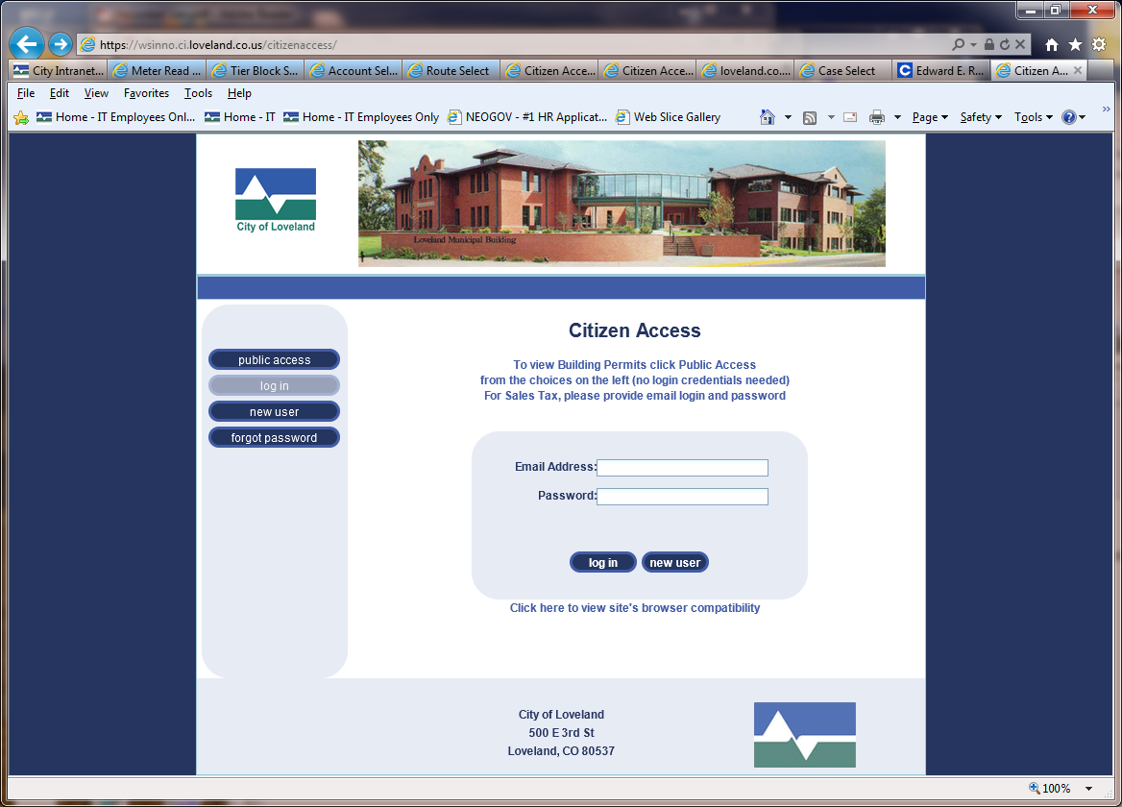

- Select the Public Access button

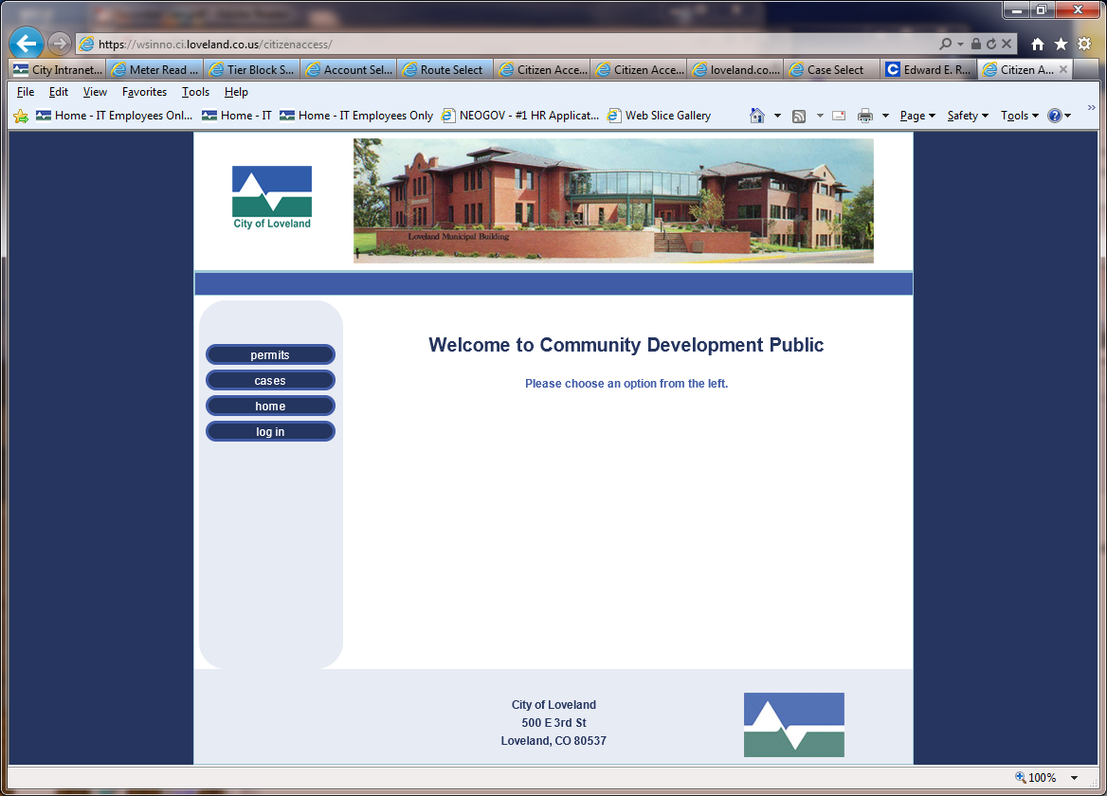

- Select the Cases button
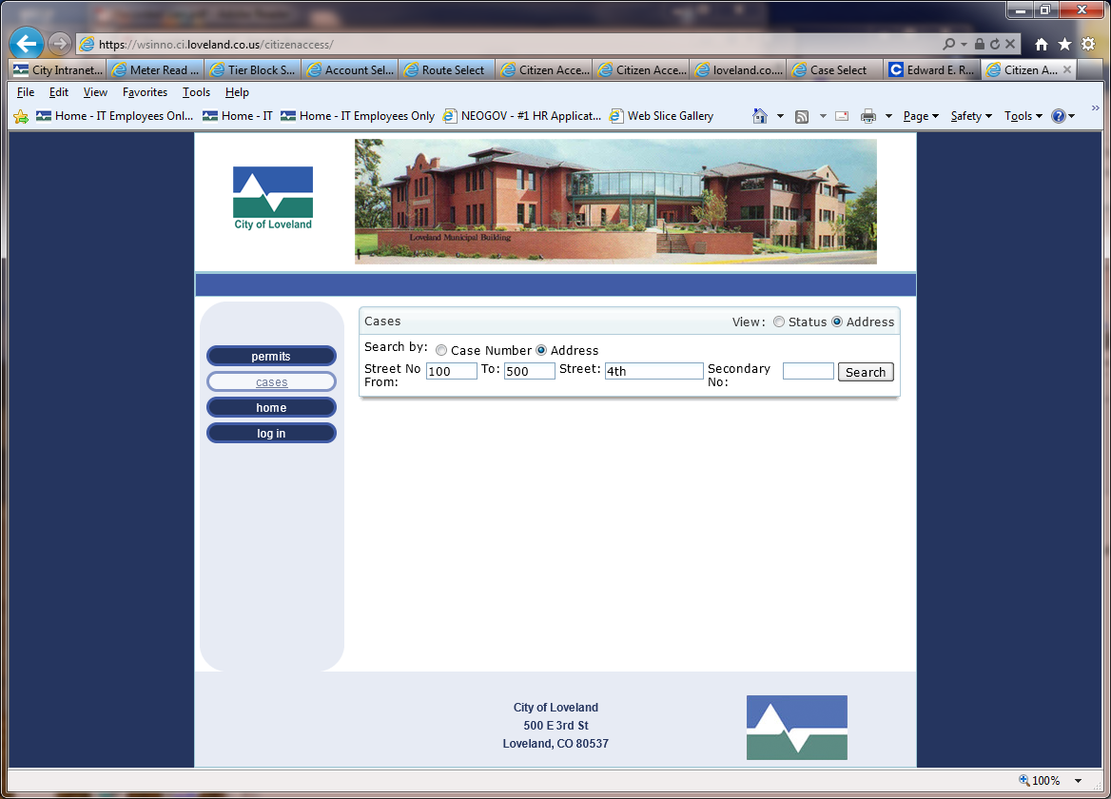

- Input the Address or range of addresses. Example shows 100 to 500 4th
- Select Search Button

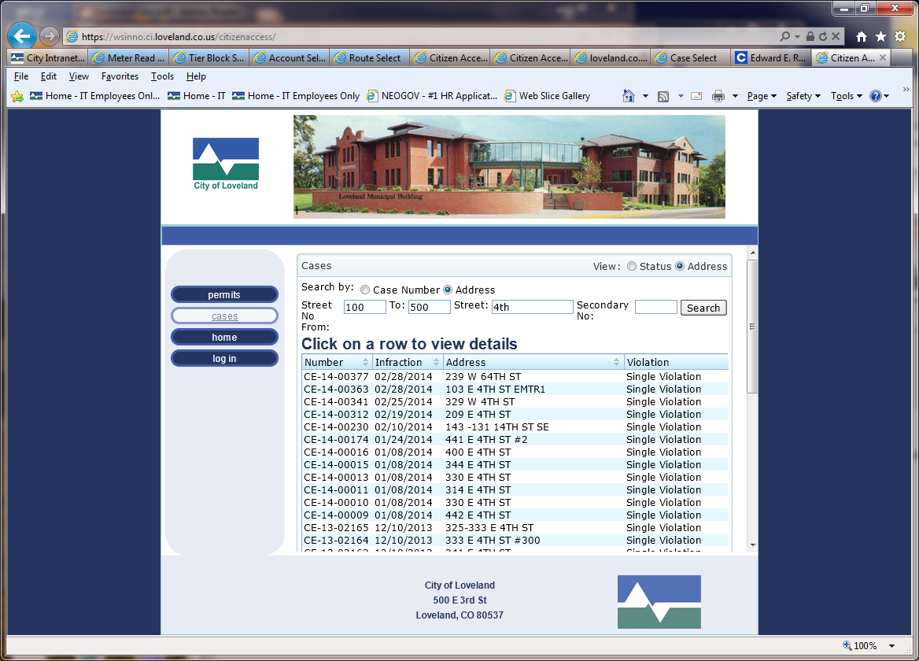
- You can see the range of address. The scroll bar will scroll you through the addresses.
- Highlight an address to select
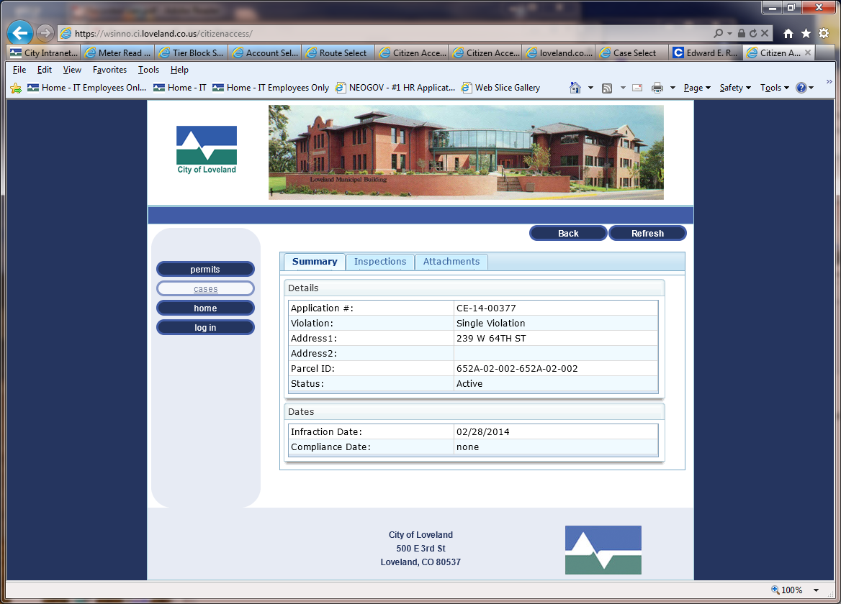
- The information for that address will be shown.
- Each tab ‘Summary’, ‘Inspections’, and ‘Attachments’ will show you what is associated with the Code Enforcement Case.
- This is the ‘Summary’ view
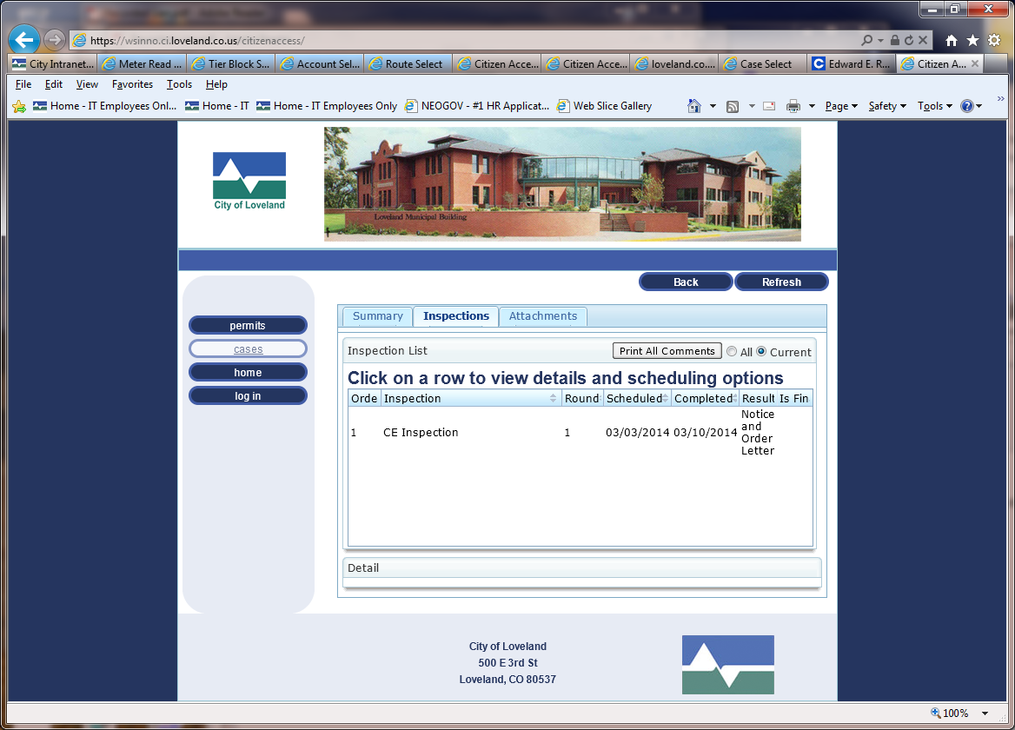
- The Inspections view screen
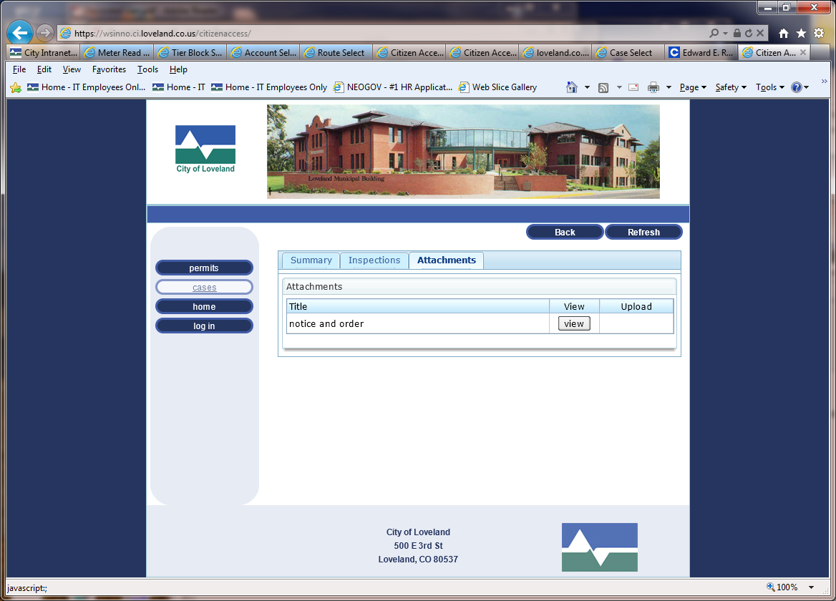
- The Attachments screen
  - If any correspondence is attached to the case then it can be viewed here.
  - Click on view to view the document. The documents can be viewed in Microsoft Office Word.

