HOW TO MAKE A BRAIN FUNCTION PUZZLE
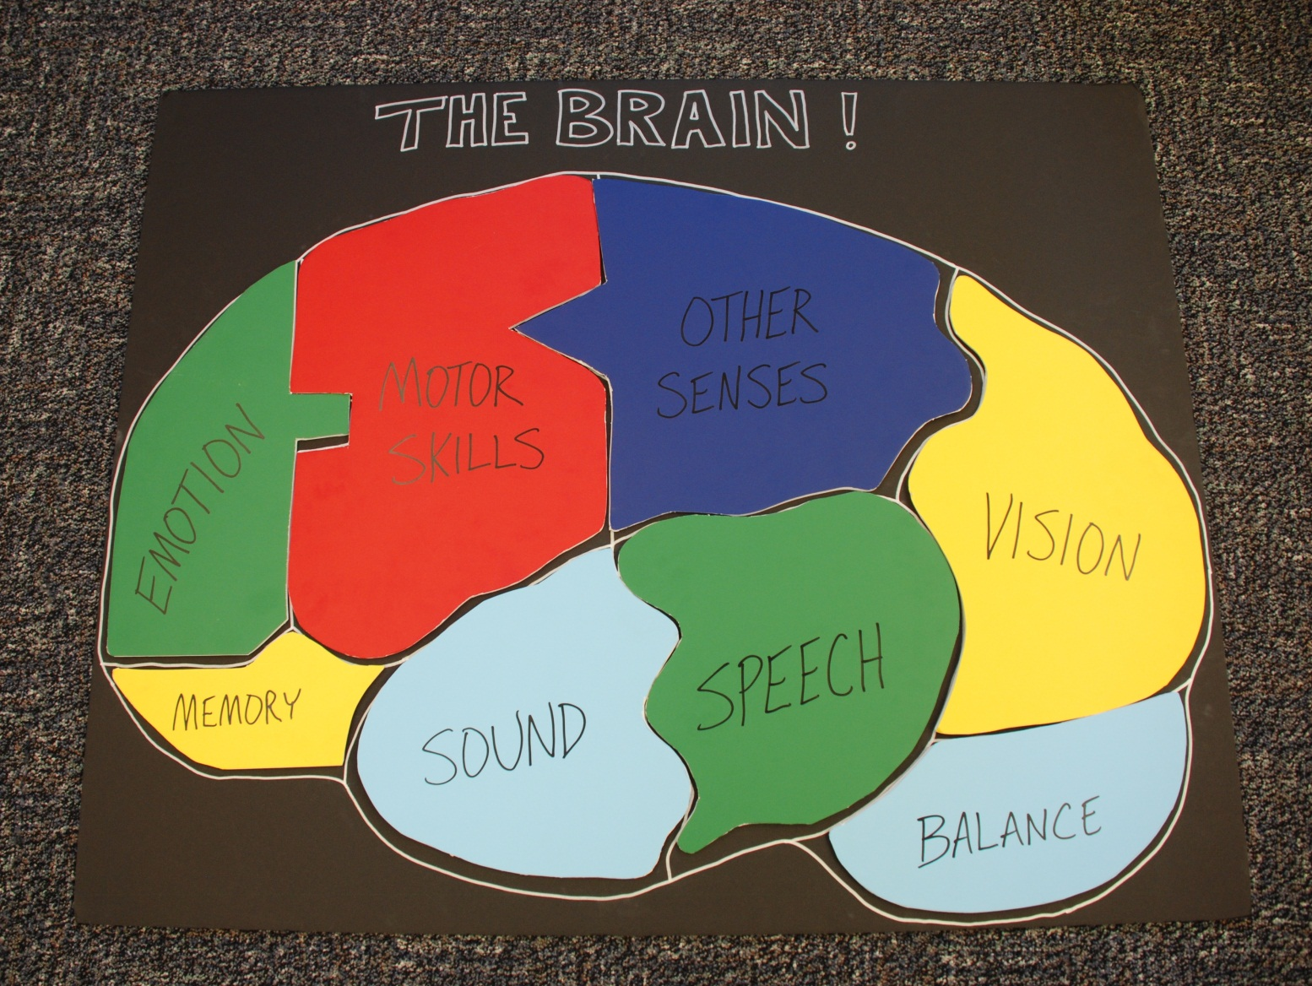

Items needed:
- 1 large, thick poster board (either black or white is probably best), approx. 3’ x 4’
- 1 large sheet of tracing paper
- 1 pencil
- 4 to 6 colored foam boards (a variety of bright, light colors is best)
- Stick-on Velcro strips
- 2 paint pens (1 black, 1 silver, or whatever will show up on the foam board colors you choose.)
- 1 sharp box cutter or sturdy scissors
How to build it:
- Draw an outline of the side view of a brain on your large poster board with the pencil. Leave room at the top for the heading.
- Still using the pencil, draw in the shapes of the eight (8) interior “pieces” that will represent the various brain functions that you will feature.
These are the stick-on Velcro strips that are used later for attaching the puzzle pieces.
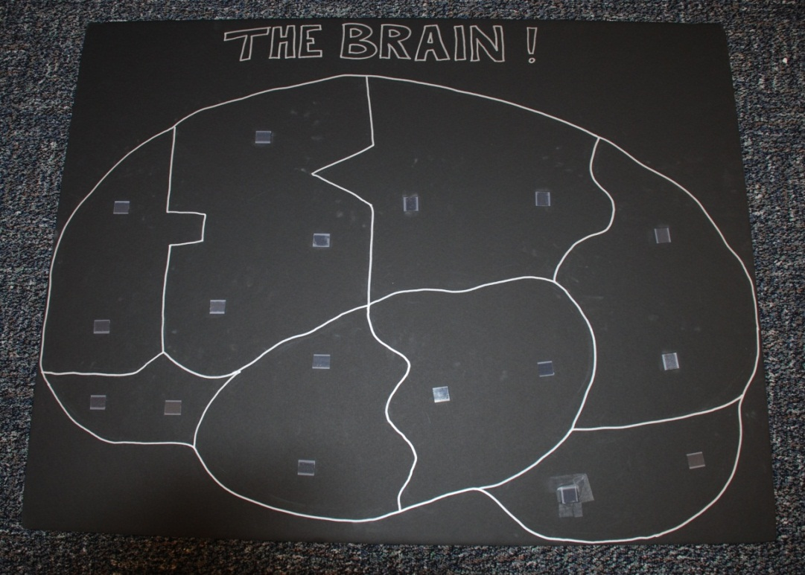
- Place the tracing paper on the poster board and trace the same size shapes of the brain outline and interior “pieces”, then cut the tracing paper into those individual shapes.
- Trace the individual puzzle piece shapes onto the colored foam board material. Try to use a variety of colors and keep them spread out from each other if any color is used for more than one puzzle piece.
- Once you have the shapes all set for the different puzzle pieces on the tracing paper, cut them into individual colored foam board puzzle pieces. These are the 8 puzzle pieces:
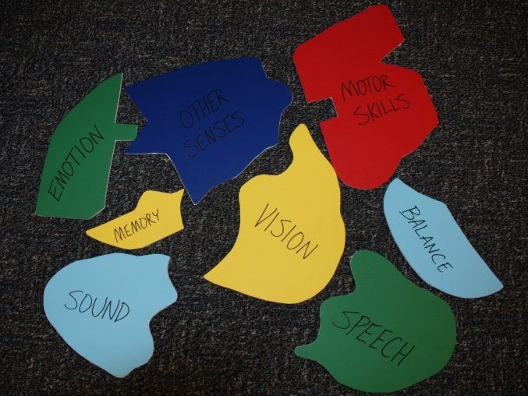
  - Vision (or Sight)
  - Sound (or Hearing)
  - Speech
  - Memory
  - Balance
  - Motor Skills
  - Emotion
  - Other Senses
- You should then slightly trim the edges so that there will be about ½ inch of space between each puzzle piece when they are on the main poster board. This will allow the outline of the shapes to show as pieces are added to the main puzzle poster board.
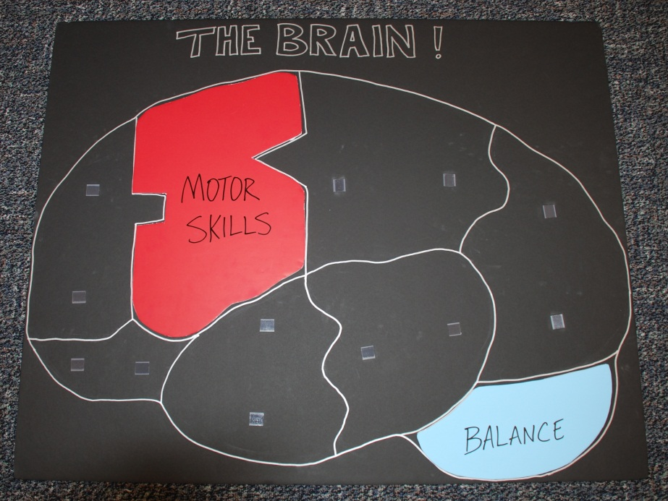
- Once everything is trimmed and fits nicely on the main puzzle poster board, attach small pieces of Velcro strips to the backs of each puzzle piece and attach the other half of each strip to the main puzzle poster board. Be sure that the Velcro strips line up properly to allow the puzzle pieces to be attached in the correct positions.
- Use the paint pens (or markers) to label each puzzle piece, draw in border lines for the puzzle pieces, and to put a title (“The Brain”, or “Functions of the Brain”) on the main poster board. Finished product should look similar to the photo on the first page.

