Station Tours 101:
A Guide to Effective Fire Station Tour Presentations
By Scott Pringle
Deputy Fire Marshal
Loveland Fire and Rescue

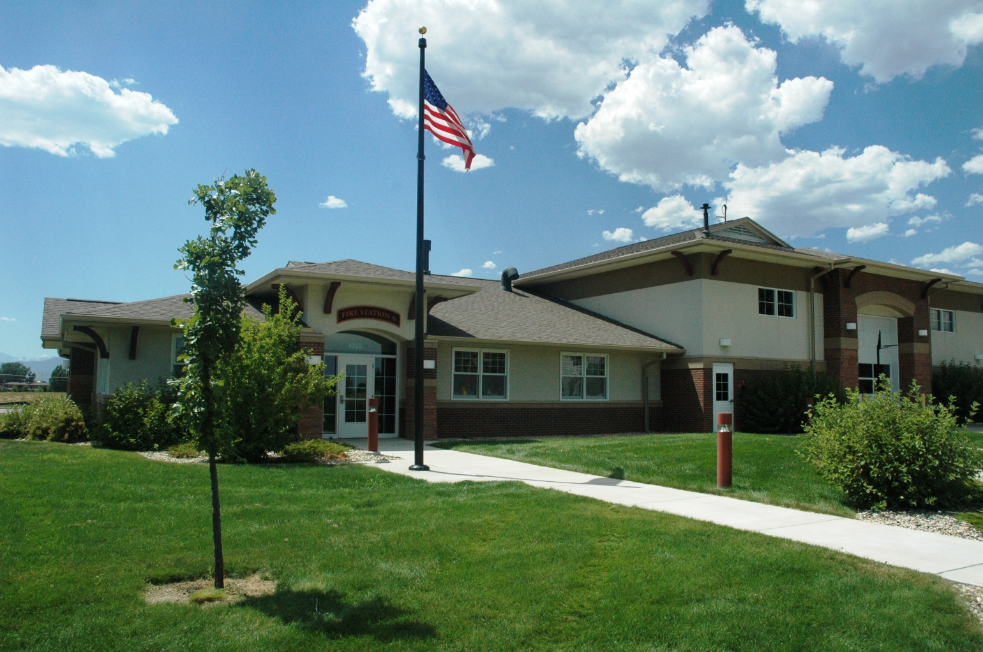

Station Tours 101: A Guide to Effective Fire Station Tour Presentations

Overview –
The purpose of this guide is to provide you and your department members with a “toolbox” of potential topics which can be presented during fire station tours for the public. As you know, fire station tours occur with a wide range of variables. Tours may be pre-scheduled appointments or unexpected “drop-ins”. They can come in many sizes, ranging from single visitors to large groups. The age ranges of your target audiences are typically anywhere from pre-school aged children to older adults, and comprehension levels can widely vary as well.
This guide will provide you with a variety of tools that you can choose from to meet the needs of your specific tour.

Know Your Audience –
It is essential to the success of your tour presentation to meet the needs of your target audience. Keep in mind that you may have a variety of target audience levels within the same tour group. While adults typically bring children to the fire station for their learning and “entertainment value”, it is important to remember that some of your presentation should also be intended for the adults as well. Never pass up an opportunity to gain the support of the residents in our community. Station tours can provide you with an excellent opportunity to educate the public on specific details involving staffing levels, equipment needs, budget issues, or other pertinent topics of discussion. You may be able to gain voter/taxpayer support of your programs and budgetary needs.

Have a Plan –
Knowing the general format of your presentation will help you to be more effective. Even an unexpected “drop-in” tour can be planned for in advance. Have an idea of the general format that you would like to use based on the size of the tour group, the ages of the group members, and the expected amount of time allotted for the tour. No two tours will be identical, but you can establish a general sequence of events for each tour that you conduct. Be sure to make a good impression by having the station and apparatus in a clean and orderly manner before the arrival of any scheduled station tours.
Having a short pre-tour briefing with your entire station crew can be helpful to ensure that the tour goes smoothly. Make decisions ahead of time about specific crew member assignments and roles for the tour. Whenever possible, set up any props that you might need to use for the tour before your visitors arrive.

Safety First –
Since we don’t want any accidents to occur during a station tour, be sure to remove any potential hazards, such as trip hazards and water puddles in the truck bay that could result in a slip or fall. Remove any ice and snow on the sidewalks leading to the station’s entrance door. It is also important to ensure that tour groups are continuously supervised to ensure that no one wanders into an unsafe area, or gets near any potentially hazardous equipment, such as chemicals, tools and equipment that are often present in the fire station. Certain equipment and areas should be off limits to visitors, such as the fire pole and exercise equipment.
Since station crews and apparatus are generally always “in service” for emergency response, it is important to prepare your audience for the potential for a quick and unexpected departure. Begin each presentation with a brief explanation that the crew is “on duty” and may be called away for an incident response at any time. Brief your audience on the proper actions that you will need them to take if that situation arises. You must be sure that your entire audience is quickly and safely moved out of harm’s way if the apparatus needs to leave the station. If no fire department staff members will be staying to continue the tour, it is essential that the tour group is quickly and politely escorted out of the station before the station crews leave. Offer to reschedule the tour at a later time if the tour was not near its planned conclusion.
Depending on the audience, it may also be a good idea to set some ground rules about the tour as well. With some audiences, especially children, it can be helpful to explain up front when and how you expect them to ask questions. Don’t be afraid to require them to listen first and raise their hand to ask a question at the time(s) that you specify for open questions. The age, group size, and the general “mood” or “attitude” of your audience can all be factors in deciding when and how you choose to allow questions.

Where to Start –
Now that you’ve got a plan, share it by starting with a brief overview of the expected sequence of the tour. This sequence may be different from one station to the next, and from one tour to the next, depending on the layout and the amount of time available for the tour.
It is often a good idea to begin the tour in the station’s day room. A brief overview of the “life of a firefighter” working 24-hour shifts, and how that relates to the design and function of the fire station is a good place to start after introduction and the safety briefing.

Next Stop –
Next, you should head into the kitchen area. Here, you can explain why fire stations have kitchens. This is a great opportunity to give an interactive presentation on kitchen fire safety. For scheduled tours, you can set up a few simple props before the tour begins. This can include pots and pans on the stove to use for examples of turning the handles to the side to avoid accidental spills and burn injuries from running into or snagging the handles. Be sure to have a lid and an oven mitt handy to discuss the best way to put out a grease fire in a pan - “Put a lid on it!” Teach the concept of “watch what you heat”. You can even cover some basic fire science by giving a brief explanation of the Fire Triangle/Tetrahedron. A few important facts to review in the kitchen are:
- Kitchen fires are the leading cause of residential structure fires.
- Kitchen fires are the leading cause of accidental burn injuries. This is often because of improper reaction to a simple grease fire. Reinforce and demonstrate the concept of “Put a lid on it”.
Some optional topics here might include “watch what you heat”, how to cool a burn (use cool water), portable fire extinguishers, and the appropriate use of the 911 emergency telephone system.

Moving on –
After the kitchen demonstration, you can head to a bedroom or bunkroom. This is a great area to discuss basic fire escape planning. Topics of discussion should include:
- The importance of having working smoke alarms in the home.
- “Get low and go” to avoid smoke.
- “Get out and stay out” if there is smoke or fire in the home.
- Go to a special outside “meeting place” that the whole family is familiar with.
- Call 911 from outside the home, using a cell phone or from a neighbor’s phone.
- Early notification and early evacuation are the keys to survival.
(A quick note about terminology and safety lesson phrases – try to use consistent and appropriate wording. For example, use the term “smoke alarms”, not detectors, when discussing equipment that should be in every home. Phrases such as “get low and go”, “get out and stay out”, and “meeting place” are easy for children to learn and remember if they are used consistently and repeatedly.)
Here are some more pertinent fire safety statistics that you can share with the tour group members:
- Fires result in approximately 3,500 deaths each year in the United States. That is more than the total number of deaths caused by all natural disasters combined (such as floods, earthquakes, lightning, tornados, hurricanes, etc.).
- About 85% of all fire deaths occur in residential structure fires.
- Almost two-thirds (63%) of reported home fire deaths resulted from fires in homes with no smoke alarms or no working smoke alarms.
Source: NFPA

The Truck Bay –
Now it’s time to show off the equipment. Remember to keep things age appropriate, but be sure to direct information to both children and adults in your audience. For example, a 4-year-old probably doesn’t care or even understand how much water your truck or engine might carry, or how many GPM’s the pump is rated for. However, some adults in the audience may be very interested in this type of technical data. Cover any information that you feel is important, but also offer to answer any questions from the tour group. Most children, and even some adults, love the chance to sit in the driver’s seat, and it often makes a great photo opportunity. Be sure to think about safety, and assist anyone that may wish to climb in and out of the apparatus.
This area of the tour is a great opportunity to discuss various safety-related issues regarding emergent responses and fire ground operations. Here are some ideas of topics to discuss:
- Motor vehicle safety, including mandatory seatbelt use by all fire apparatus occupants. Encourage everyone to wear their seatbelt every time they ride in any vehicle. You can also segue into discussion about the importance of car seats and booster seats for younger vehicle occupants. For State of Colorado laws and recommendations on this topic, visit www.carseatcolorado.com, or use your state’s requirements if not in Colorado.
- “Pull to the right for siren’s and lights” – Discuss the appropriate response for drivers when they hear or see emergency vehicles in use.
- While showing and discussing the various pieces of equipment on your apparatus, you can also explain some of the operations that take place at a typical structure fire scene, including search and rescue procedures, ventilation, fire attack, etc. Discussing the required manpower to safely operate on a fire scene can be an enlightening experience for the adults in your tour group.

The Sky’s The Limit! –
As stated before, no two tours are ever the same. There are literally dozens of topics that may be appropriate for your audience. Feel free to be creative and come up with ideas that work well for you. Each tour is a learning experience for the audience and for the station crews. Afterwards, be sure to share both your success and failures with your co-workers, so that we can all learn to improve our presentations.
Some other potential topics of discussion could include:
- Carbon Monoxide (sources, signs and symptoms of exposure, CO alarms, etc.)
- Bike helmets, life jackets, and other life safety protective equipment
- Local emergency notification systems (such as reverse 911, outdoor warning system, etc.)
- Emergency planning, including weather radios and emergency supplies kits (www.ready.gov)
- Wildland fire safety, including defensible space, Community Wildfire Protection Plans, etc. (www.fs.fed.us/fire/index and/or www.fema.gov/hazard/wildfire/index)
- Point out sprinkler systems (if your station is so equipped) and use it as an opportunity to promote commercial and residential fire sprinkler systems (www.nfsa.org)
- Fire department budget and staffing issues – a station tour is a great opportunity to discuss and explain your department’s specific staffing and equipment needs with your local citizens.
- Any other programs or services that your department offers (car seat technicians, smoke alarm donation programs, home fire safety surveys, etc.)
Conclusion –
Once the tour has come to an end, be sure to thank them for coming and give them a chance to ask any other questions that they might have. Be sure that you have met their expectations for the tour. Remember that your professionalism and level of customer service can go a long way in gaining the support of your community members.
This is also the best time to issue any handout materials that you want them to have. Saving these to the end of the tour ensures that the handouts don’t become a distraction during your presentation, and reduces the chances of these items being misplaced before the tour group leaves the station.
If your department keeps records of public education contacts and/or maintains daily activity journals, be sure to include the data from your station tours.

Station Tour Quick Reference Checklist –
Here’s a brief list of items to consider before and during each tour you conduct:
Before the tour
- Review plan with station crew members
- Ensure the station and apparatus are clean and presentable
- Address any safety issues
- Wear the appropriate uniform
- Set up any equipment and props you may need before the group arrives
During the tour
- Introductions
- Safety Briefing
- Tour Expectations / Overview
- Fire and Life Safety Lessons
- Tour of the Station
- Tour of the Apparatus
- Photo Opportunities
- Demonstration of PPE or other equipment, when appropriate
- Conclusion / Opportunity for Questions
After the tour
- Distribute any appropriate handouts at the end of the tour
- Thank them for coming!
- Remember to record the activity according to your department protocols

